|  |
| --- |
| CAPstone PROject - creditcard fraud detection |
| advanced program in data science |
|  |
| by reshma ramesh pai, 02-apr-2023 |

# project description

CREDIT CARD FRAUD DETECTION

To build a model using machine learning algorithms for detecting fraudulent credit card transactions so that customers are ensured they won’t be charged for items they did not purchase.

* A dataset is shared that contains transactions made by credit cards in September 2013 by European cardholders.
* This dataset presents transactions that occurred in two days, where we have 492 frauds out of 284,807 transactions.
* The data is highly unbalanced, the positive class(frauds) account for 0.172% of all transactions.

# Project Workflow

* Getting the Data
* Data Cleaning and Preprocessing
* Exploratory Data Analysis
* Feature Selection and Splitting of Data
* Model Training

1. Under Sampling
2. Over Sampling
3. Logistic Regression
4. K-Nearest Neighbors(KNN)
5. Random Forest
6. Comparing the accuracy of different models

* Saving the best fit model



# Step by Step Process

Getting the Data

Importing the required libraries.

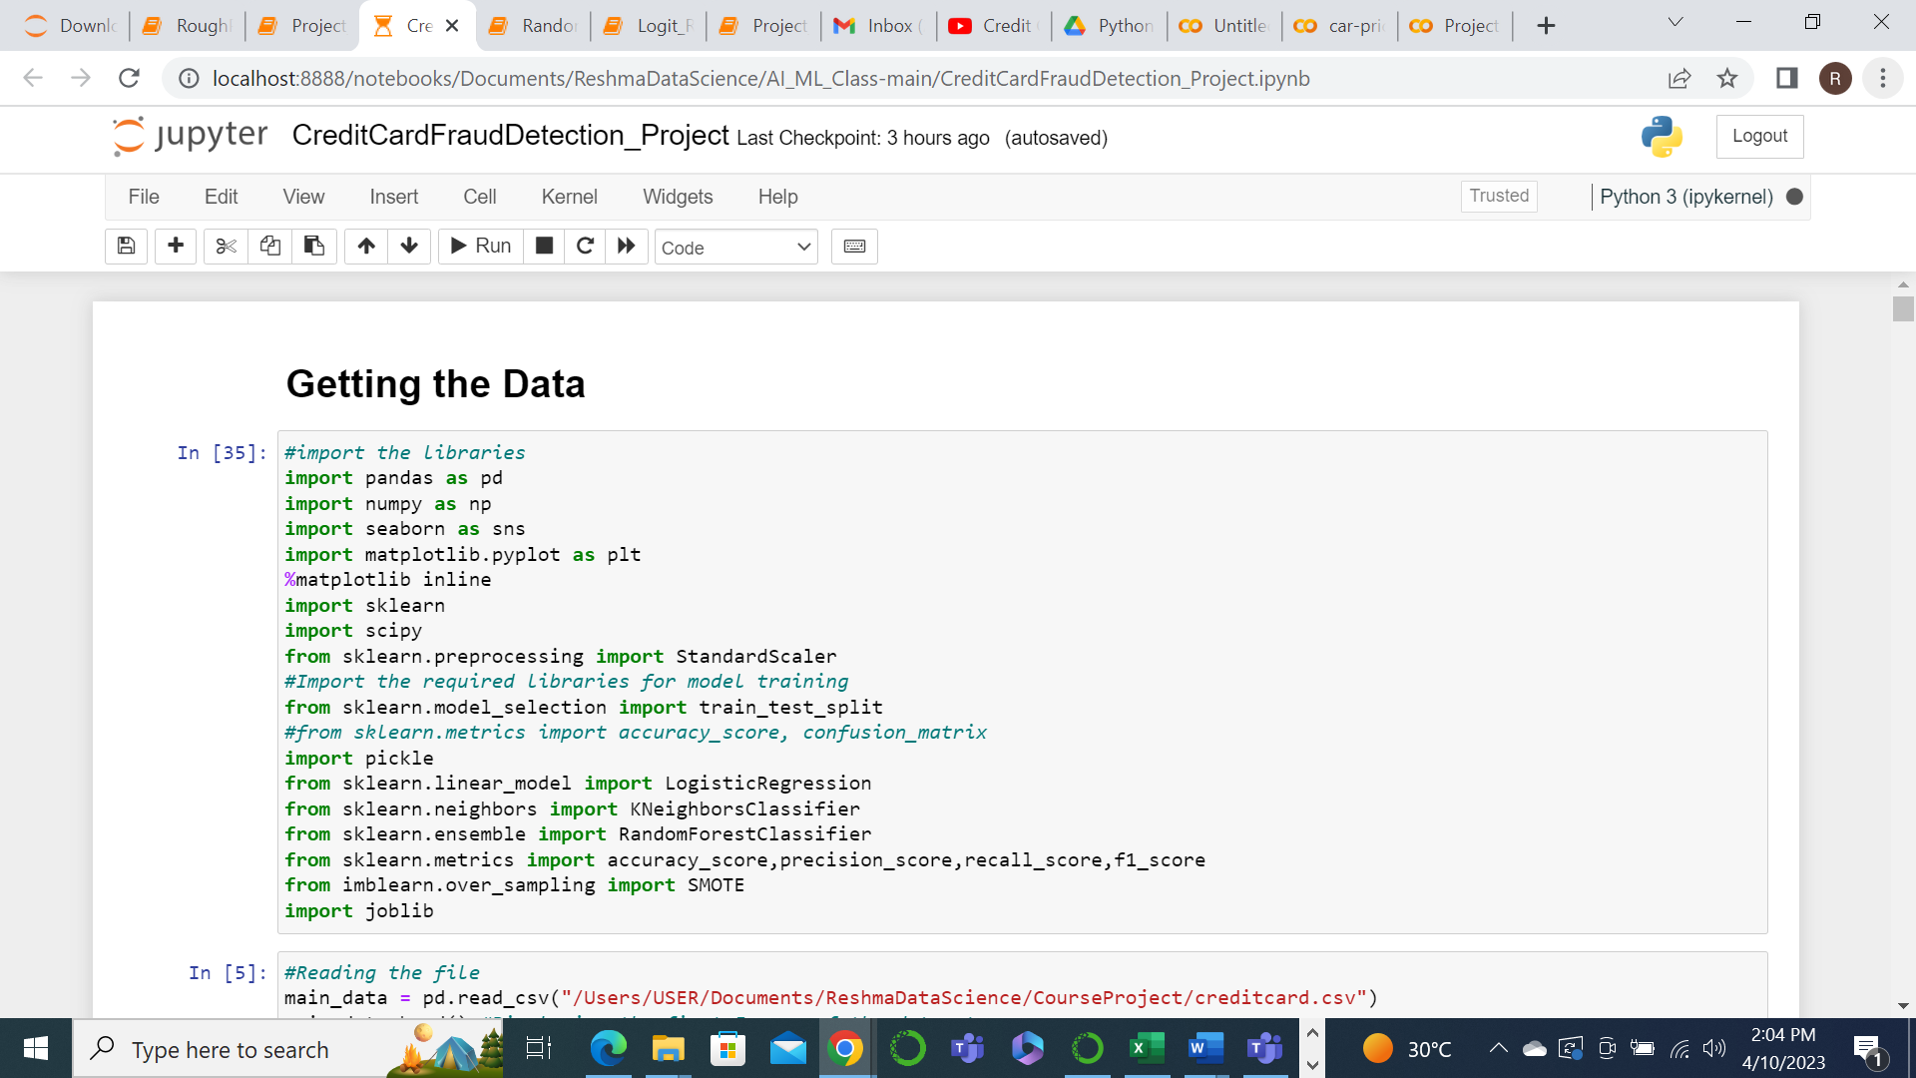

Reading the file and loading the dataset. For this we will use the read_csv function of the pandas.

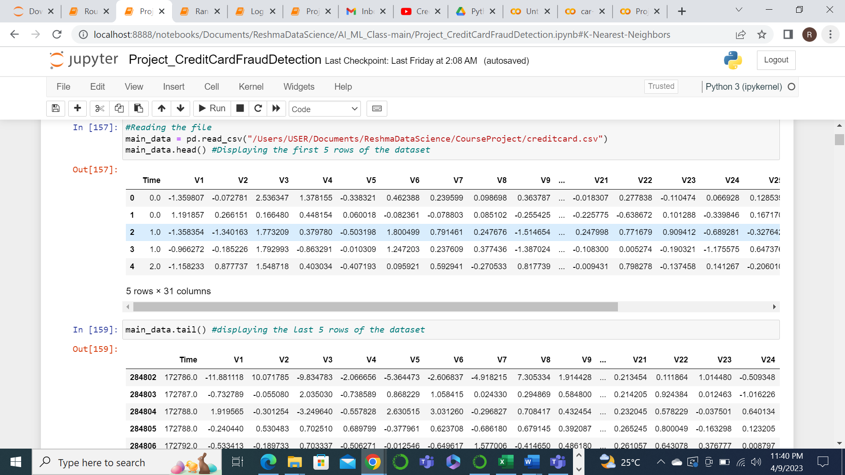

Getting the Dataset information

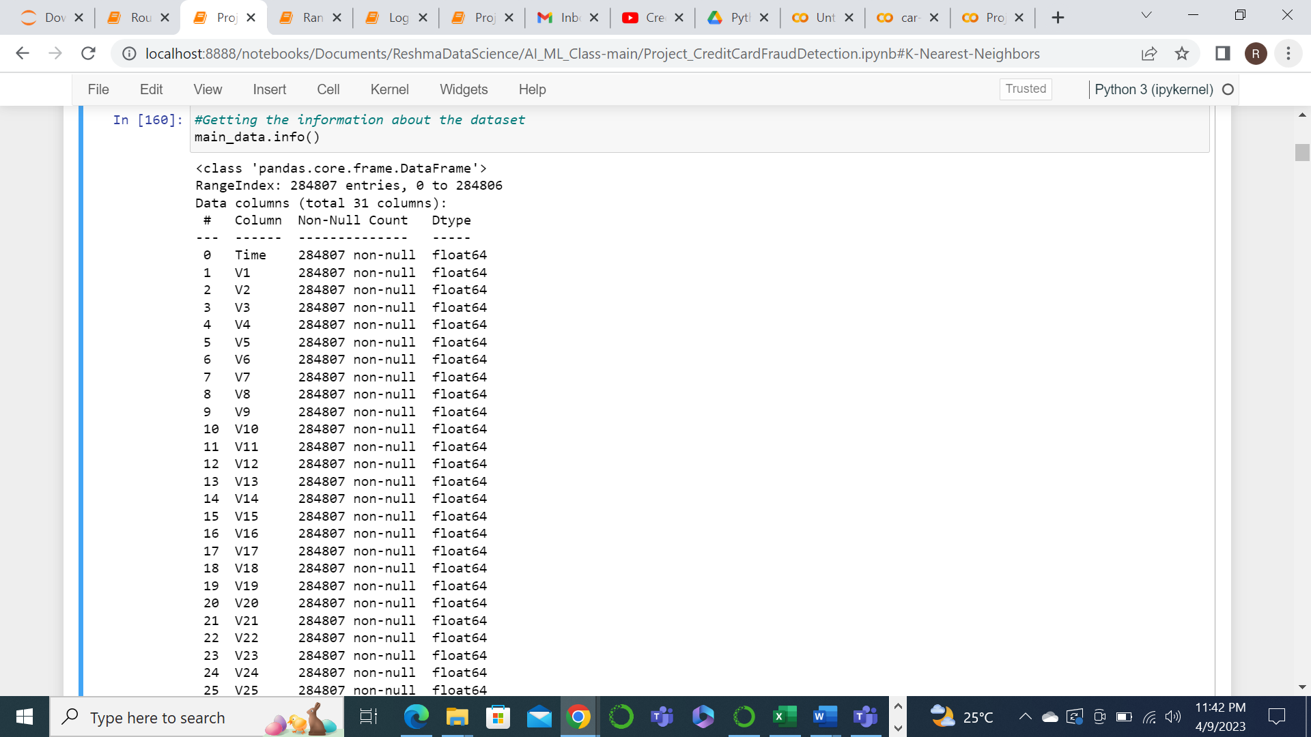

Data Cleaning and preprocessing

First we need to check if there are any null values in the data. But no null values were found in the data.

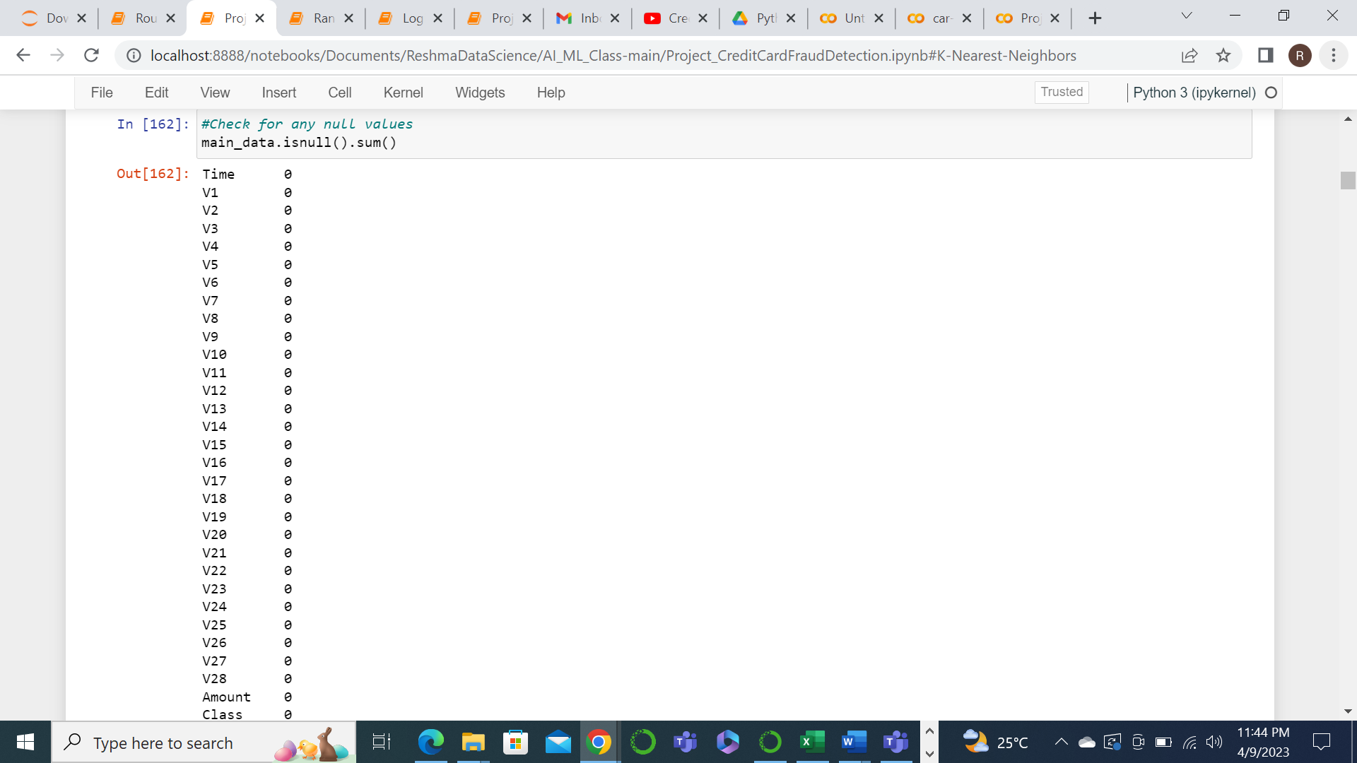

Next we need to find if there are any duplicate rows.

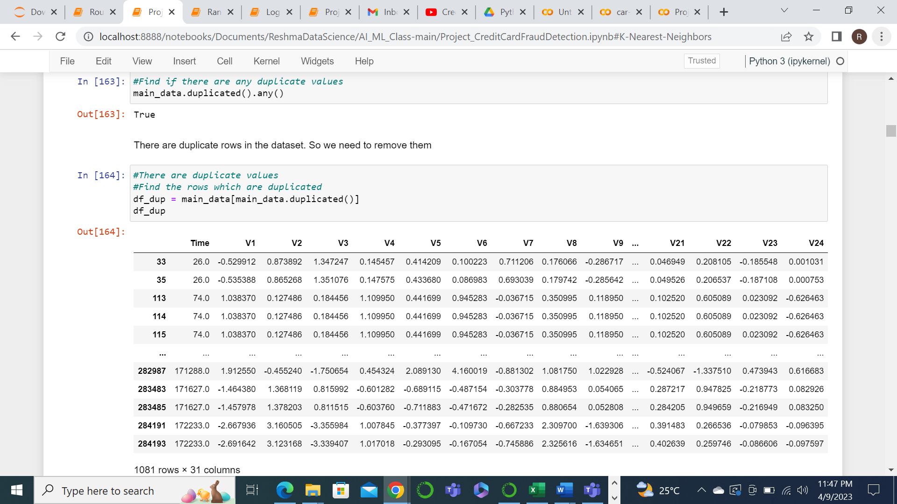

We could find 1081 duplicate rows. So those rows were removed from the dataset.

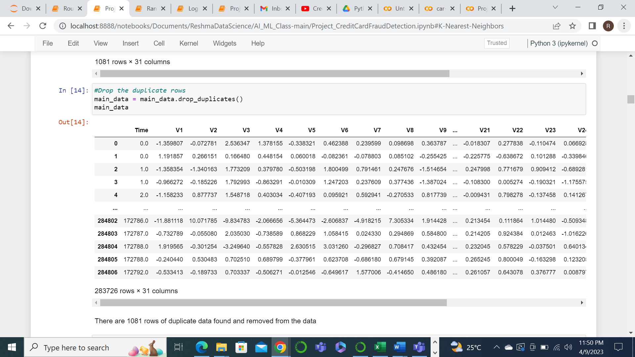

Next we will look into the statistical information about the data.

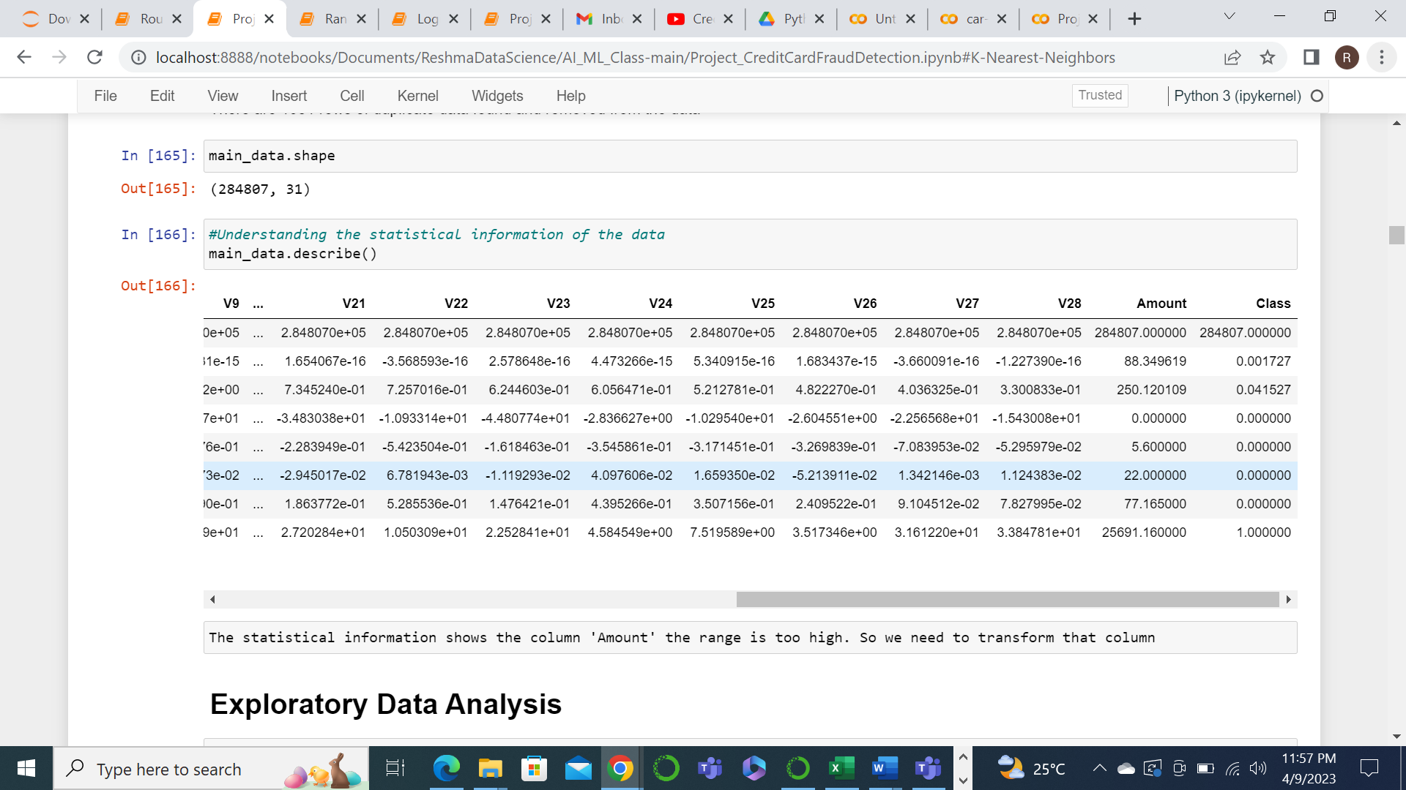

While looking into the statistics, it is understood that the values in the ‘Amount’ column is varying too much when compared to the other features. So we might need to transform the data of this column to reduce range of its values.

Exploratory data analysis

Plotting the class feature using countplot function of seaborn to understand the difference in the number of Normal and Fraud transactions. It is seen that the number of Fraud transactions are very less compared to Normal transactions which shows class imbalance. This can effect the accuracy of the or the effectiveness of the model.

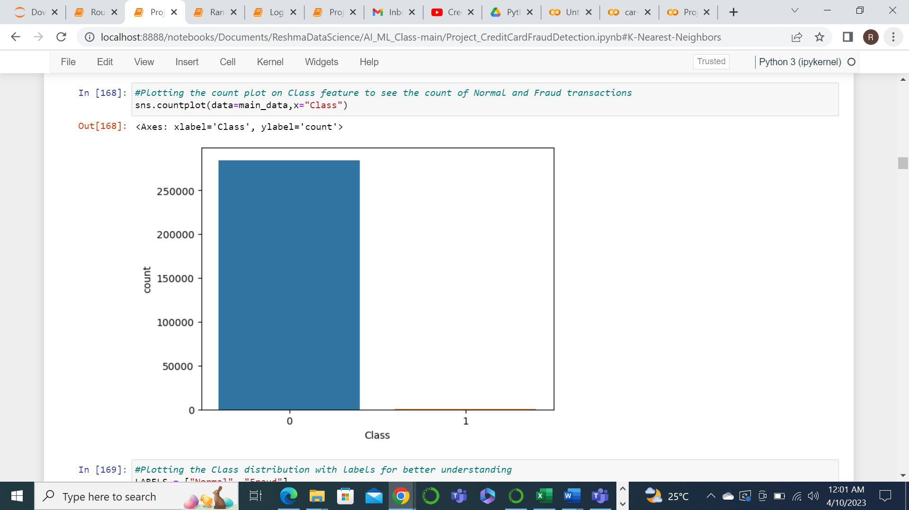

Further we are checking the distribution of data for various features.

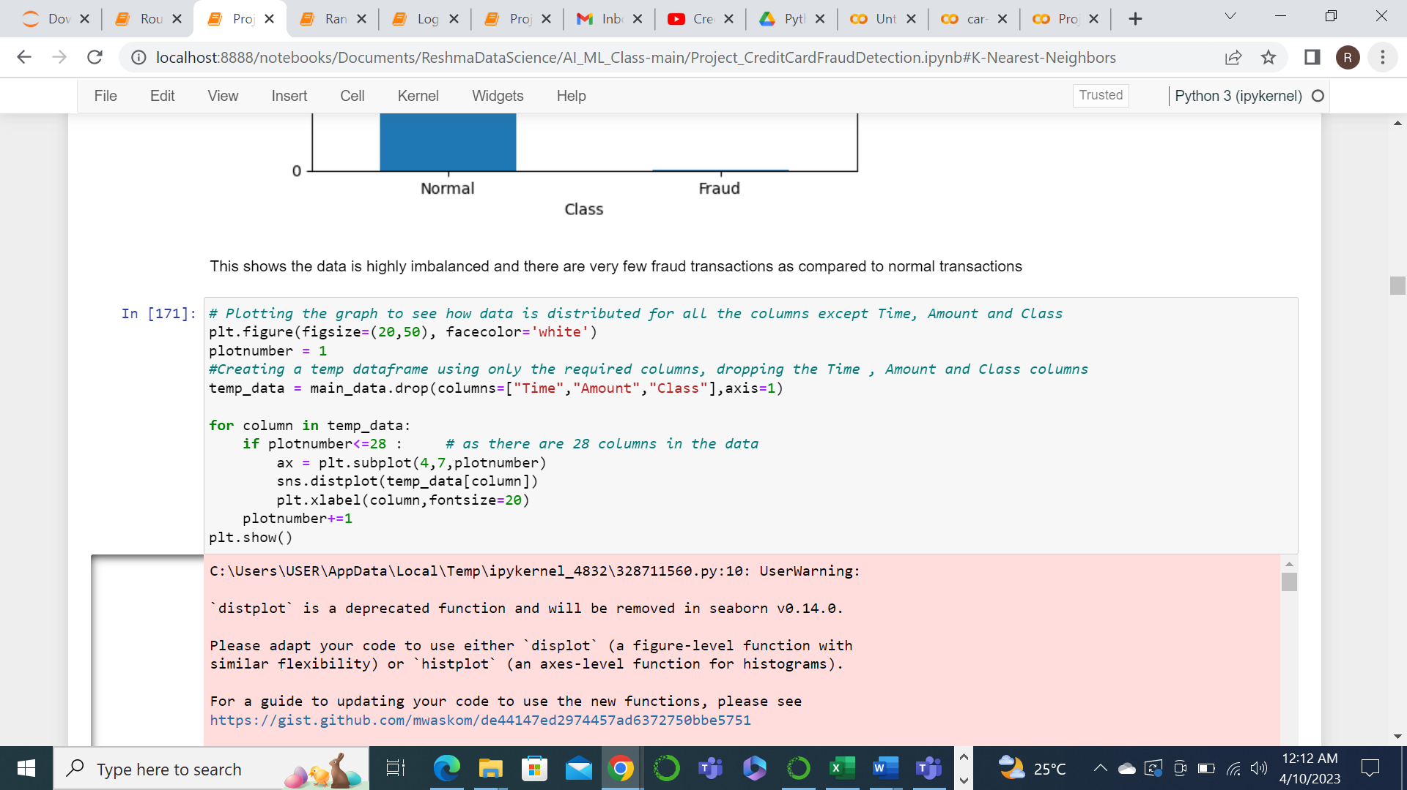

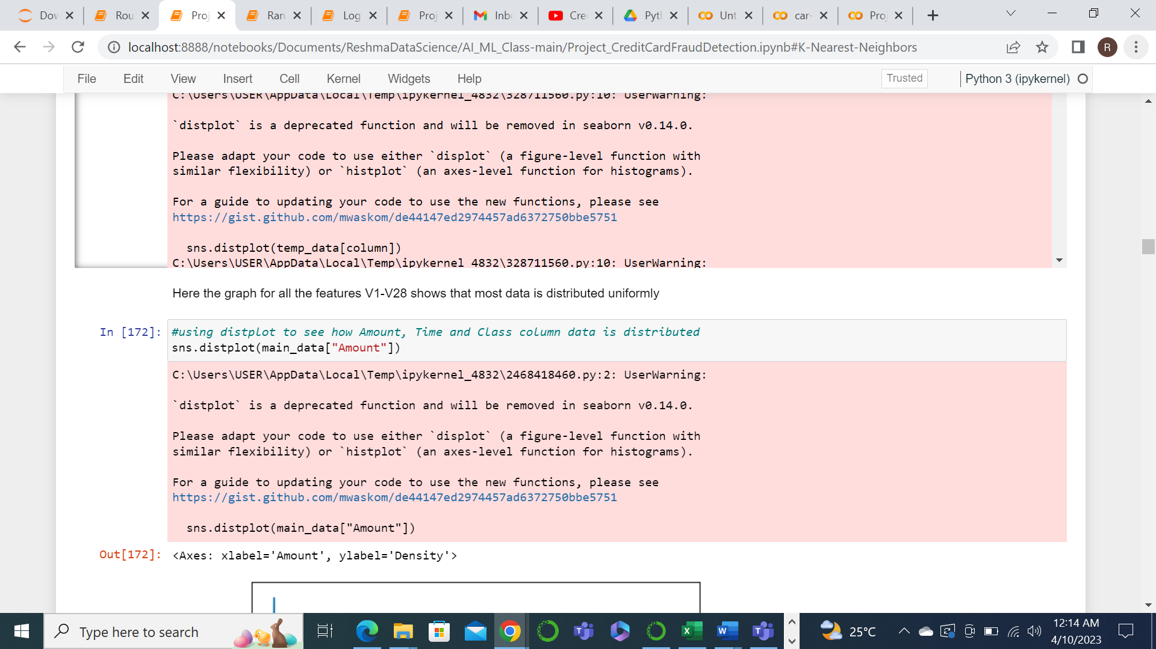

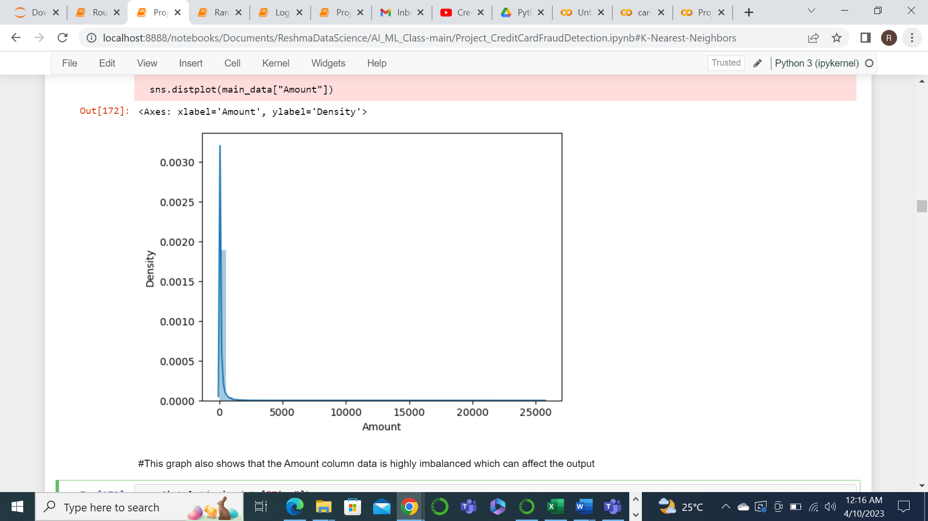

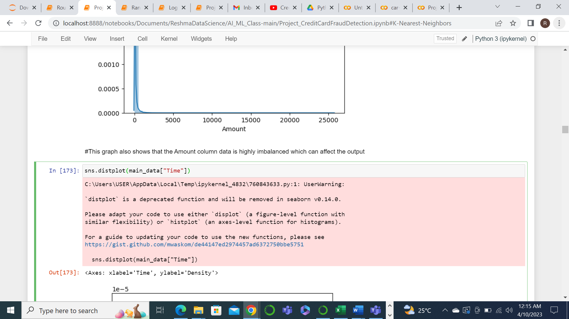

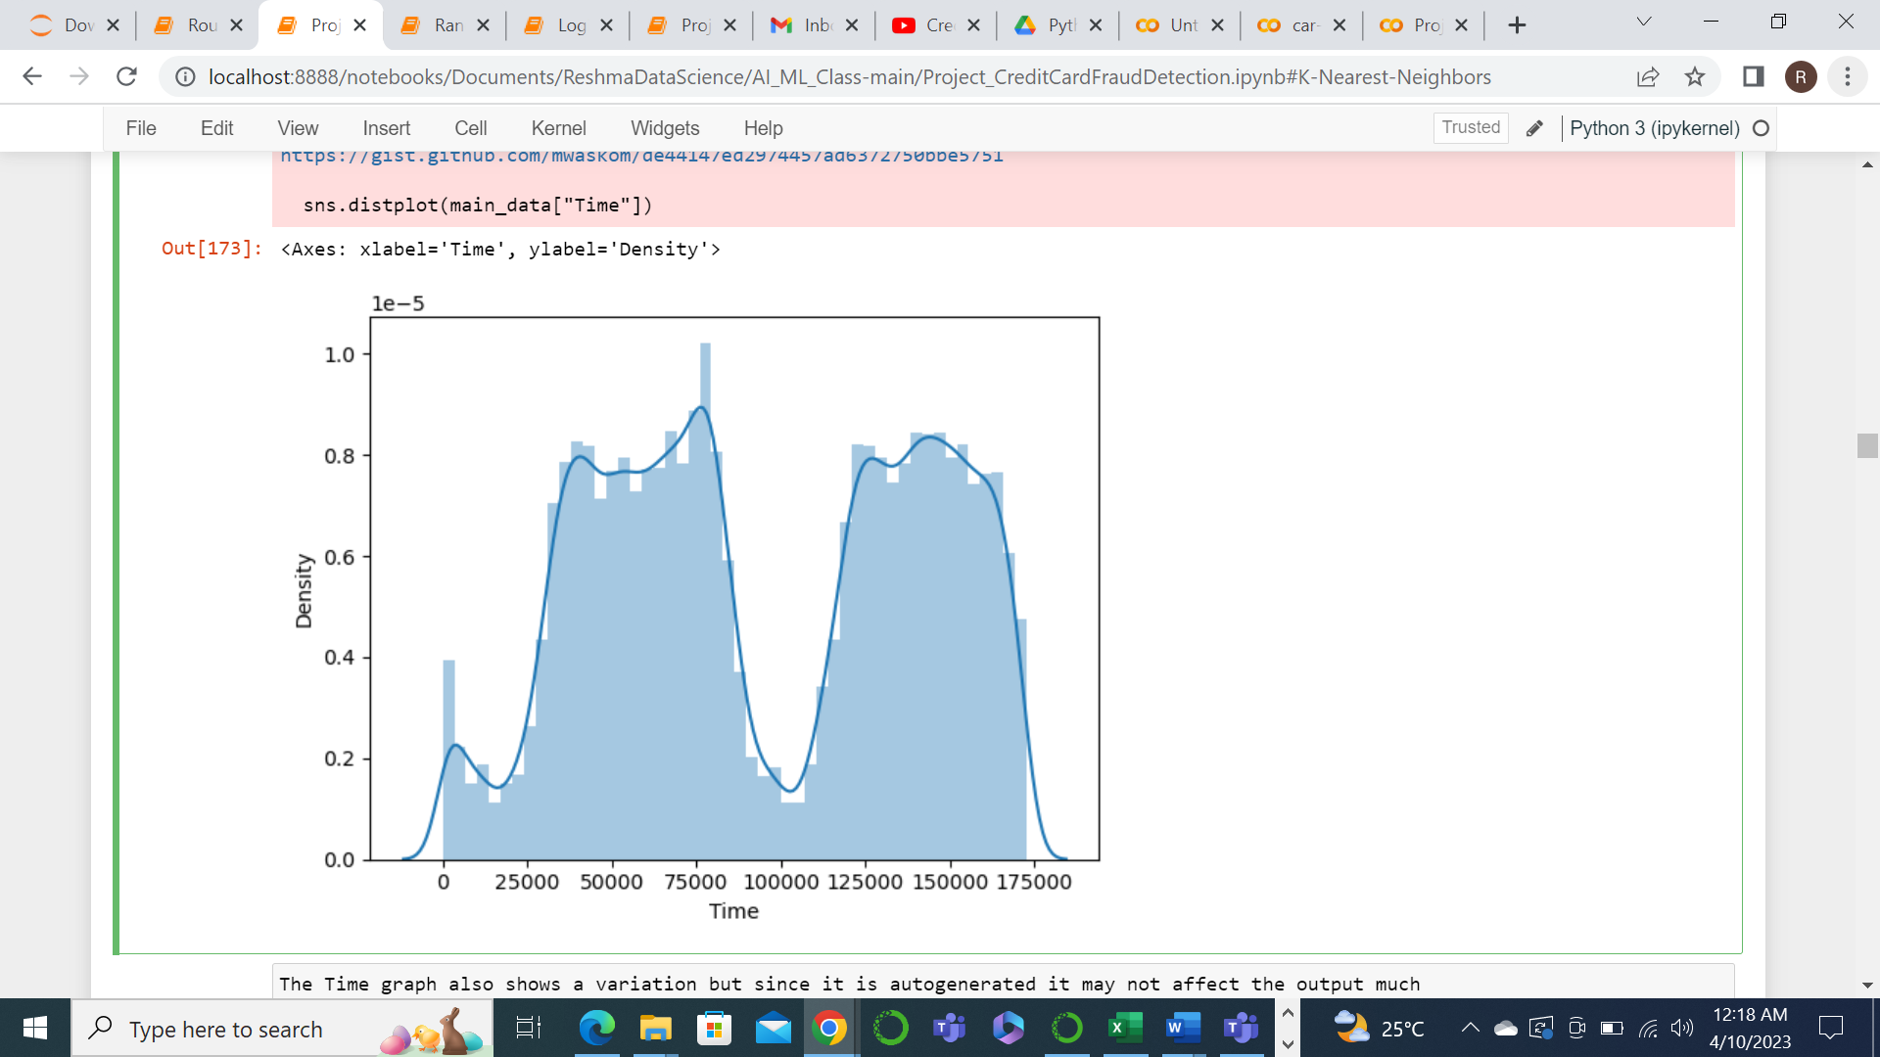

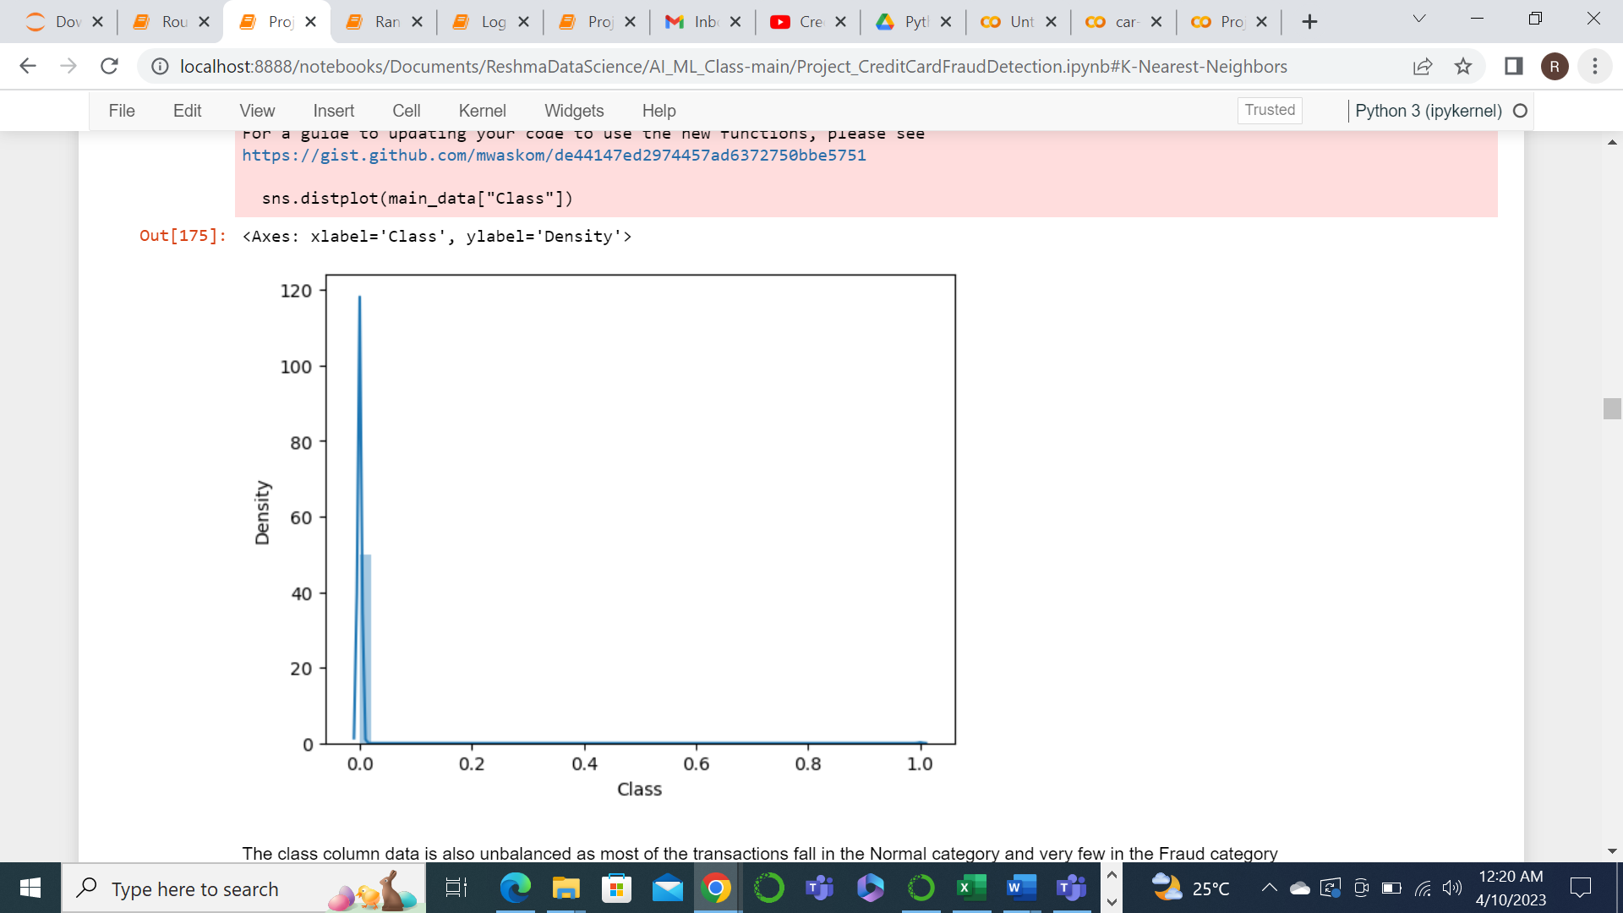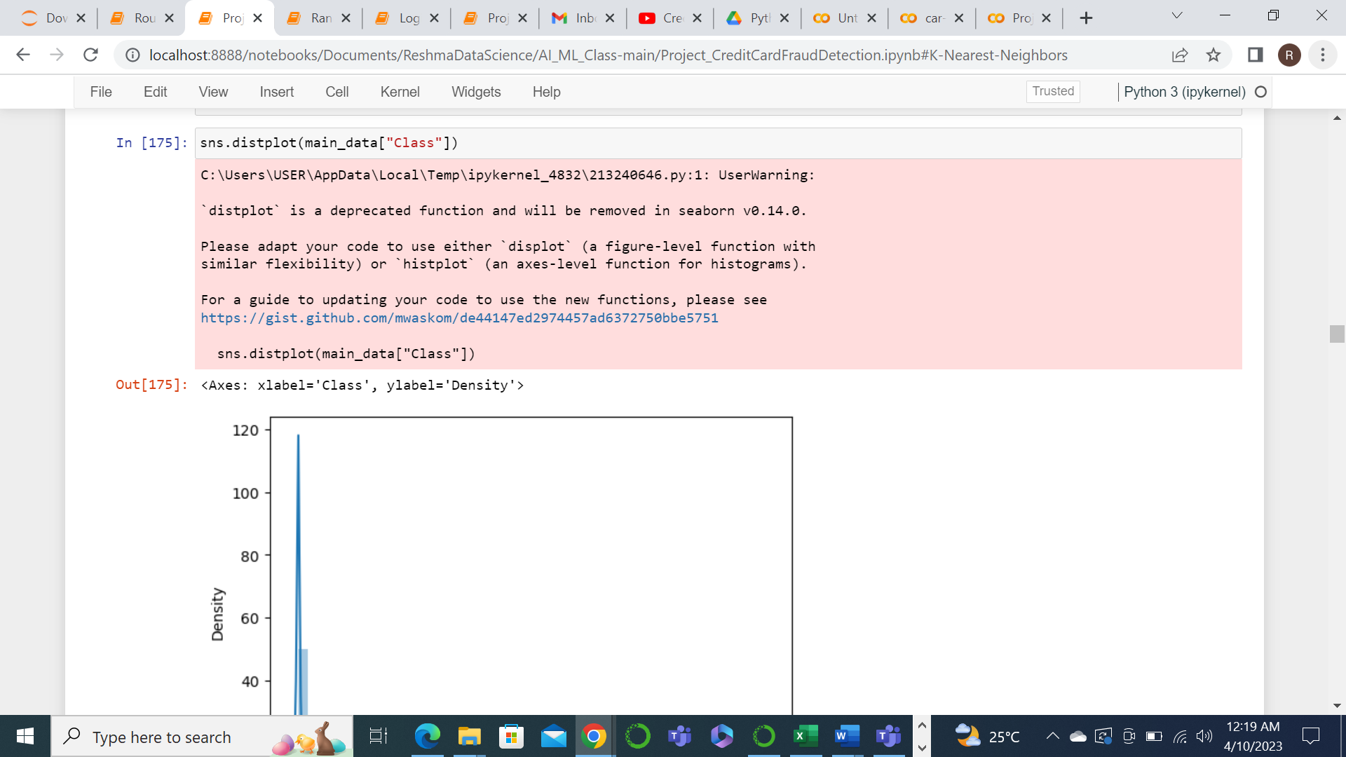

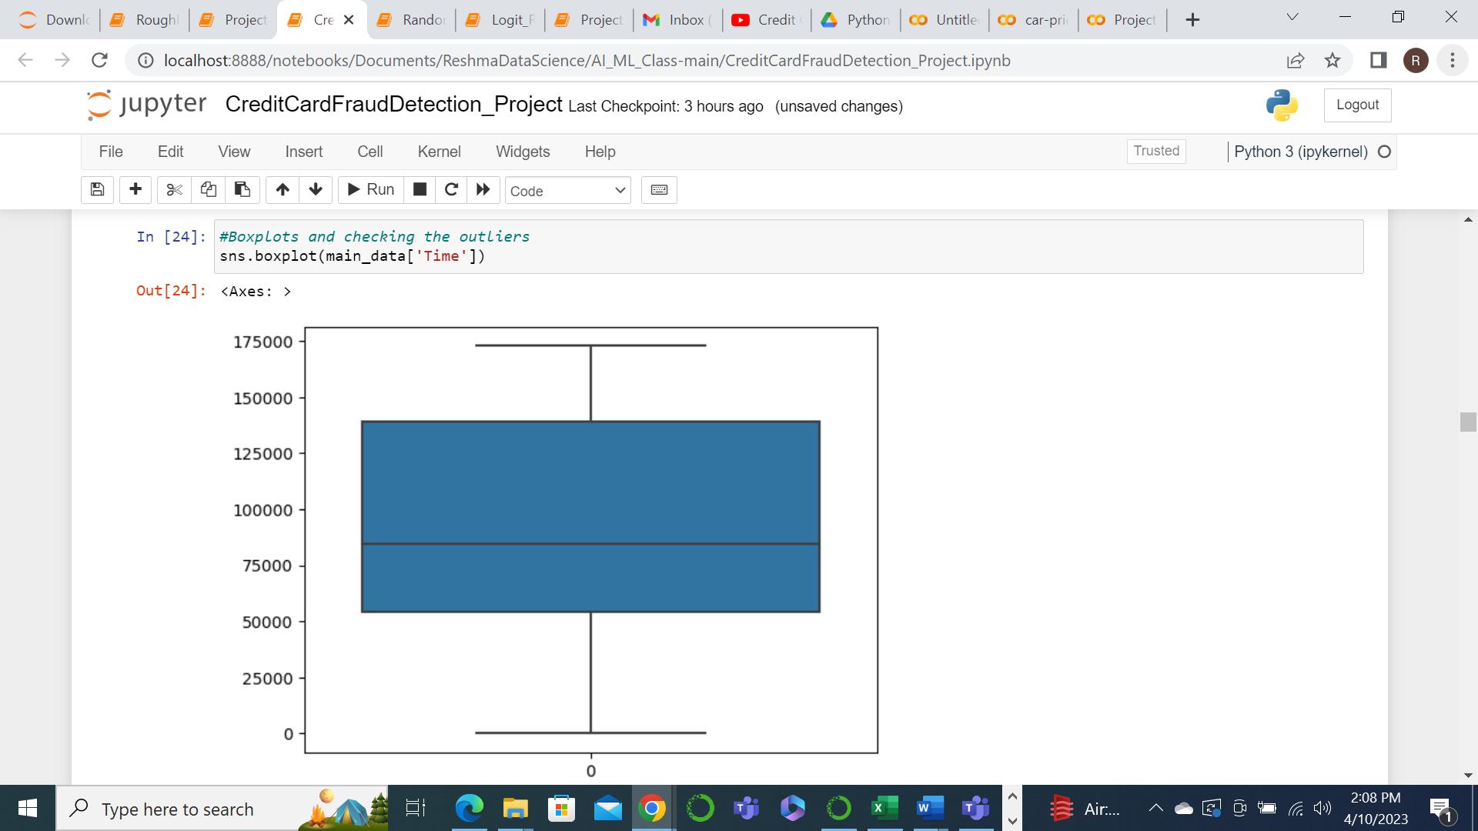

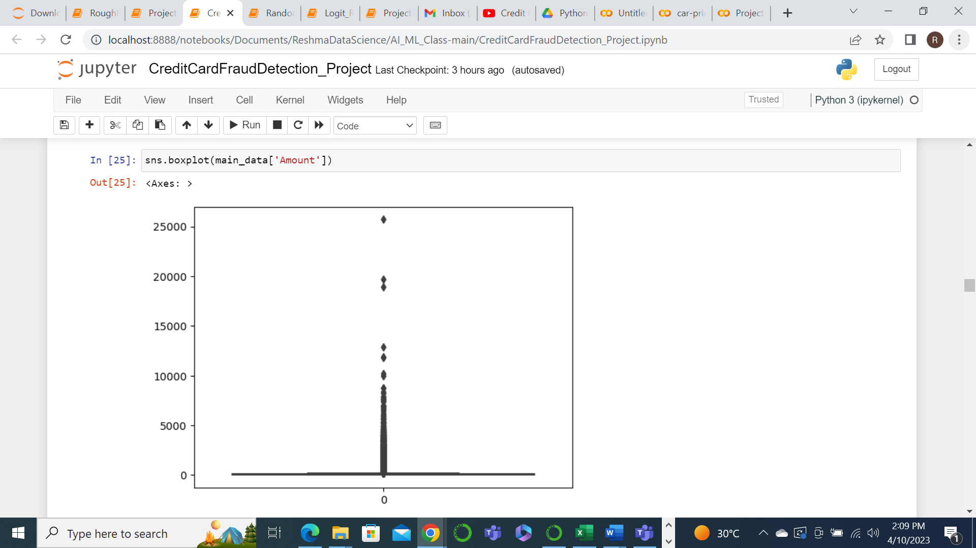

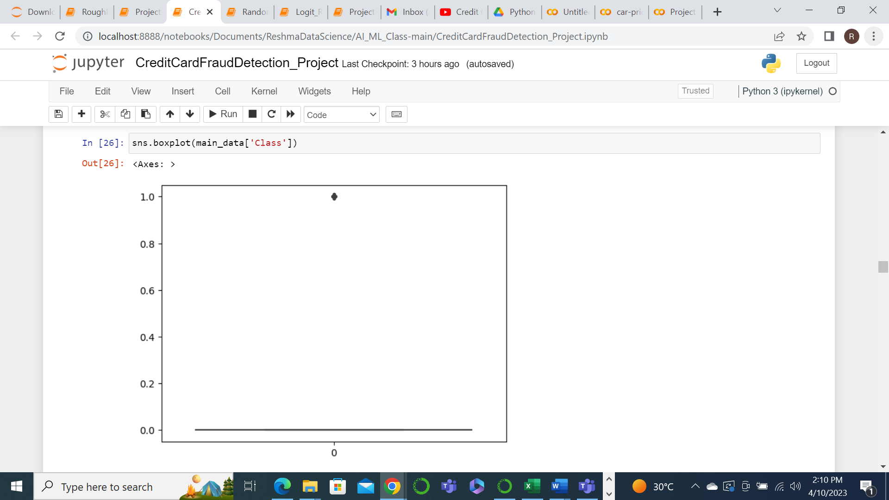

The graph for the features V1 to V28 shows that they have comparatively normal distribution where as the columns Time and Amount has huge variation. But we need not consider Time column for now as it need not affect the output as it is a just a system generated value. So the main feature to consider here is the Amount column. Since the Amount value range is too high we need to transform that column data to standardize it within closer range. For that we are using the StandardScaler function of sklearn.

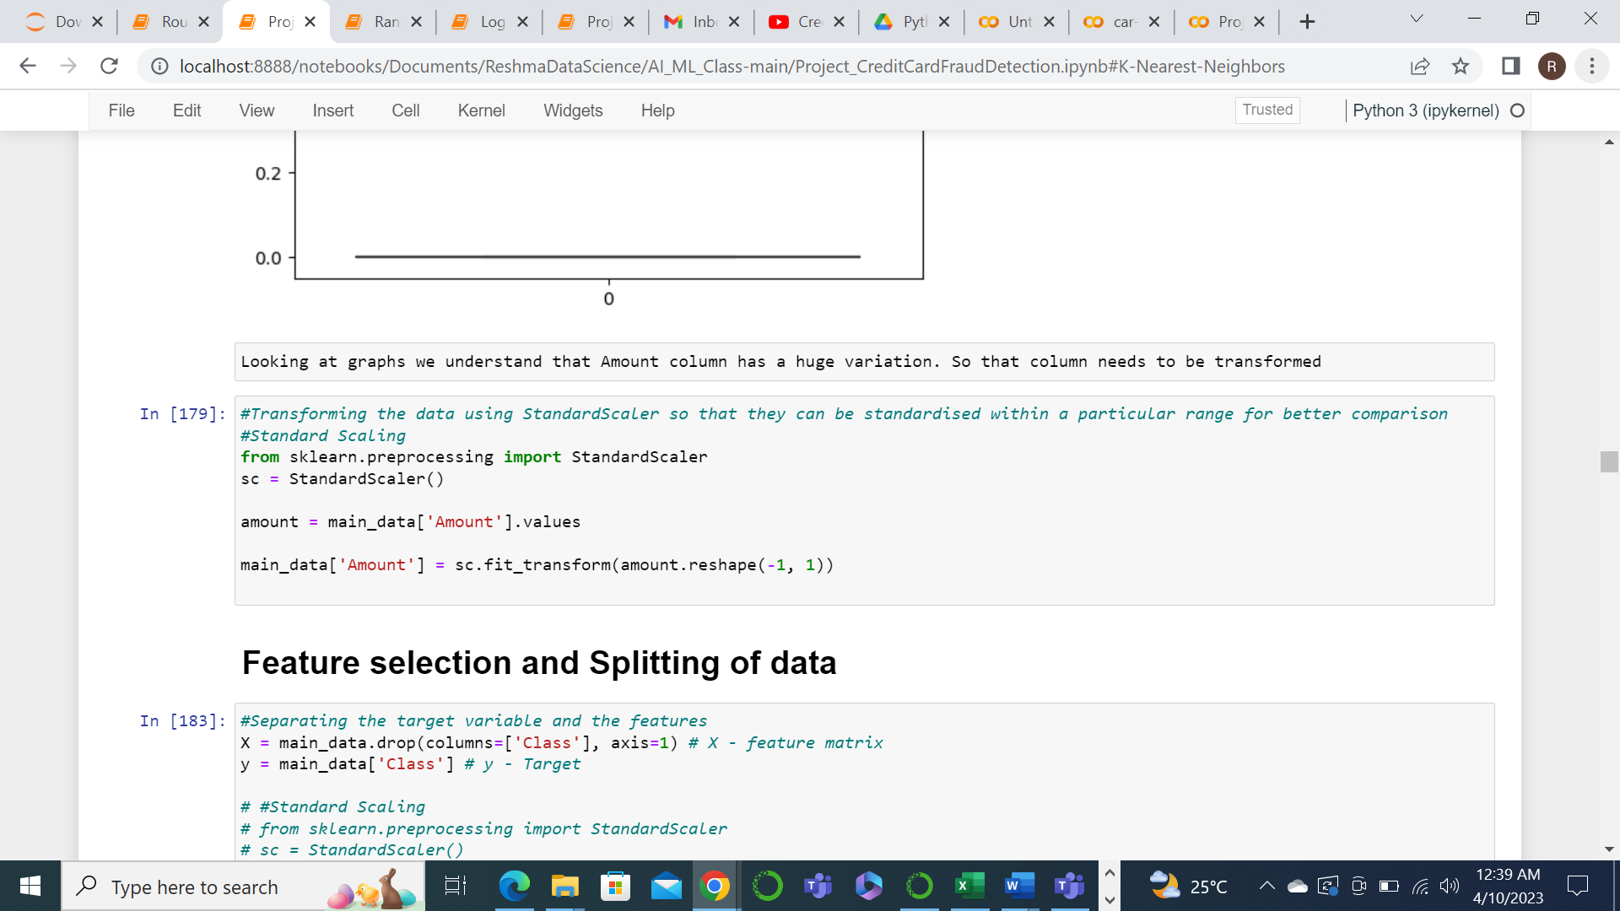

feature selection and splitting of data

Next we separate the target column and the required features for modelling. So we will drop the ‘Class’ column from the main data set and store it in a variable and store the ‘Class’ column in another variable.

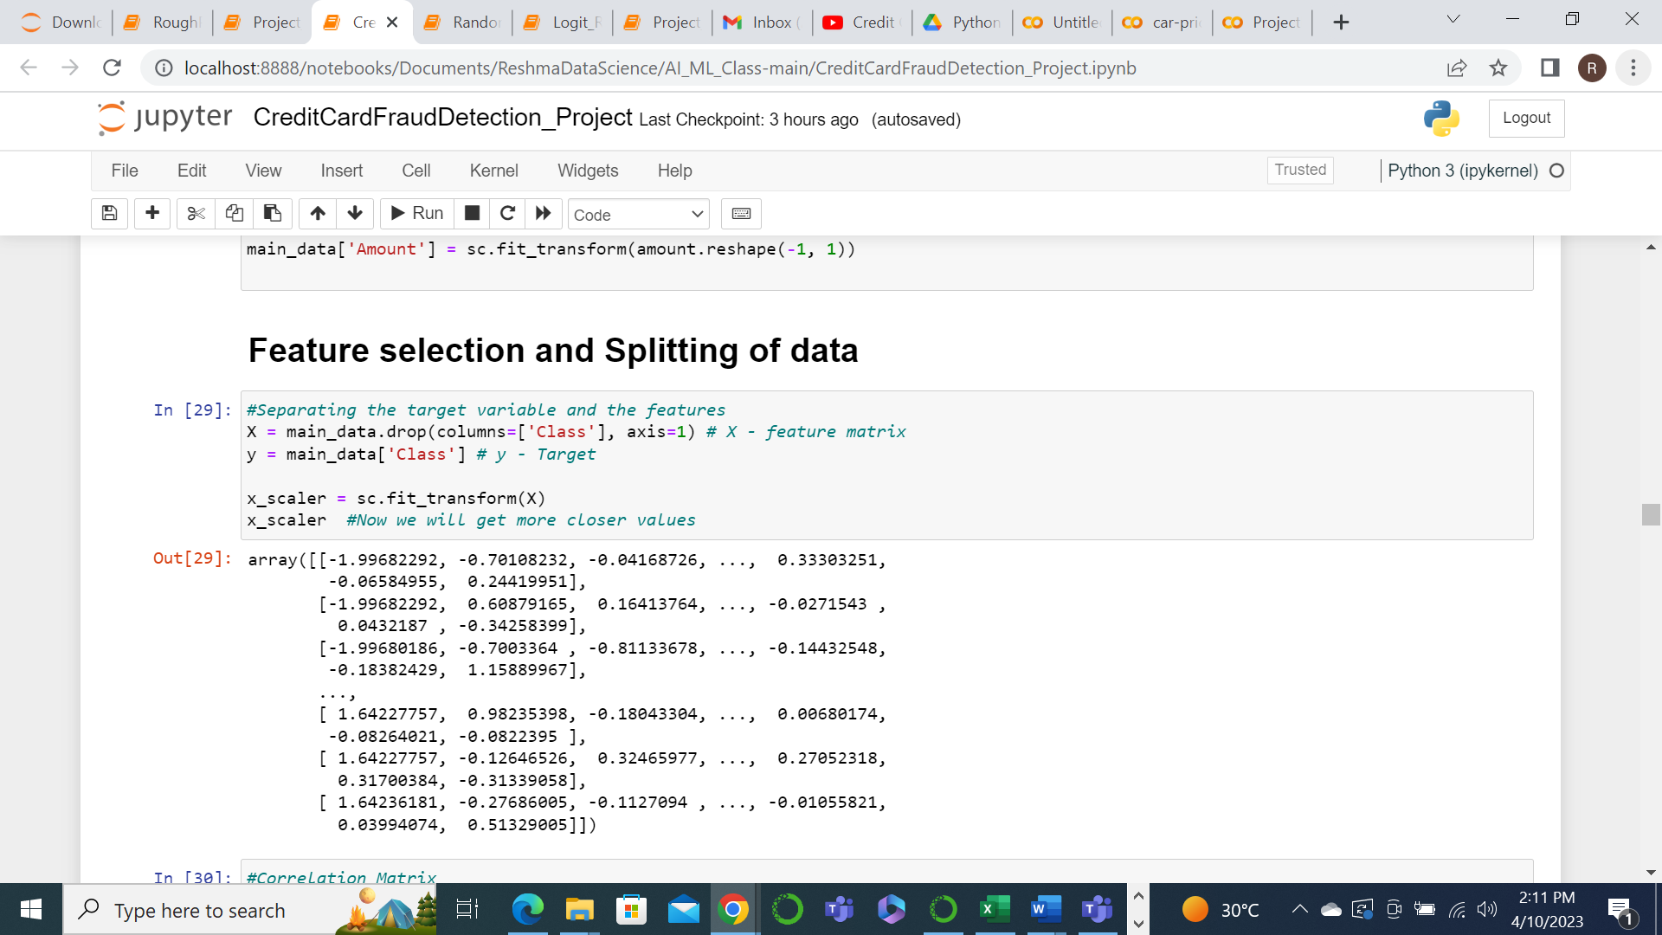

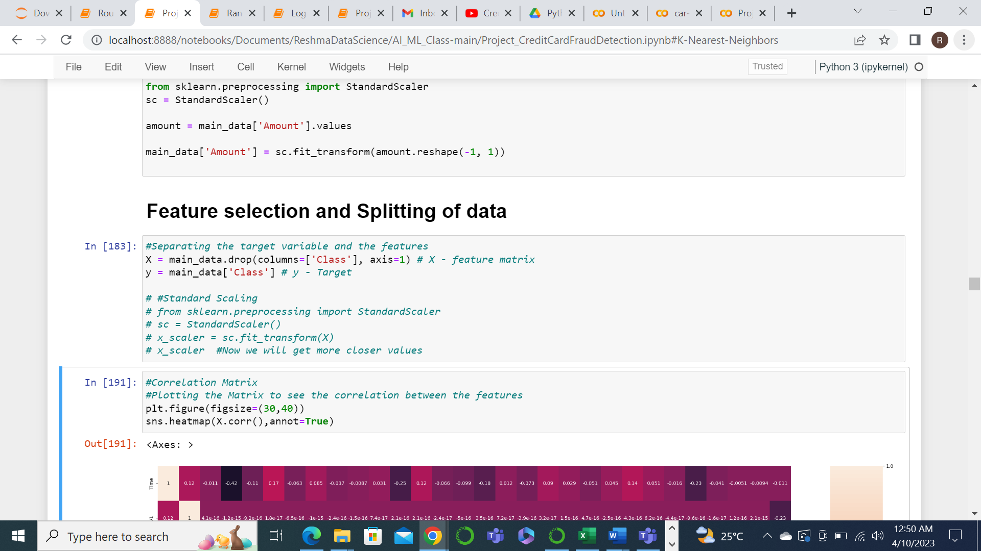

The correlation matrix also shows that the Amount column has a significant impact on the target variable.

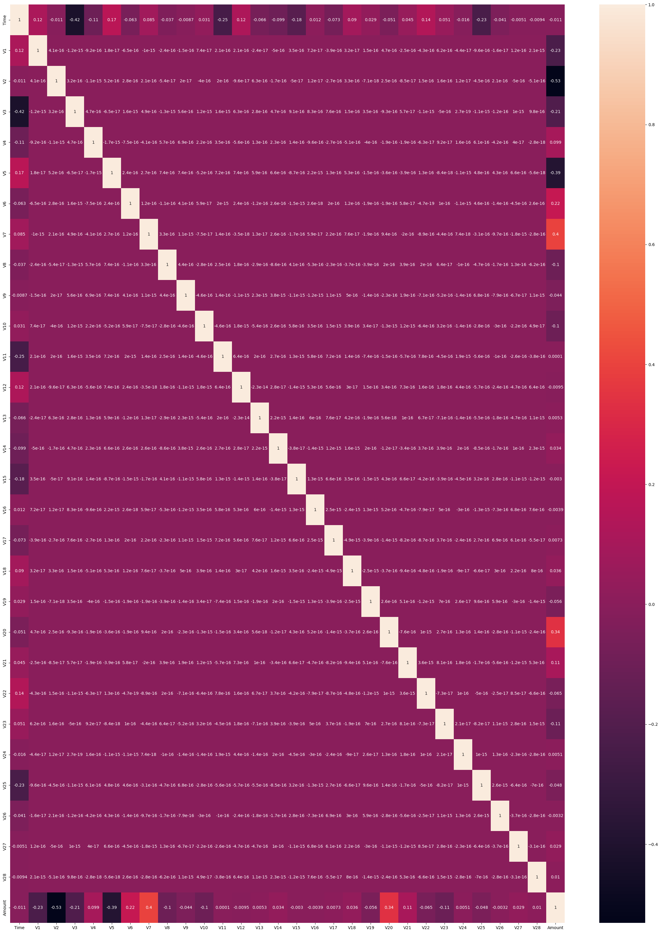

model training

In this step, we will be building different types of classification models using the algorithms in scikit-learn package. Here the type of models that I will be using are Logistic Regression, K-Nearest Neighbors(KNN) and Random Forest. These are some of the popular models used for solving classification problems.

Here first we split the scaled dataset into Training and Testing set.

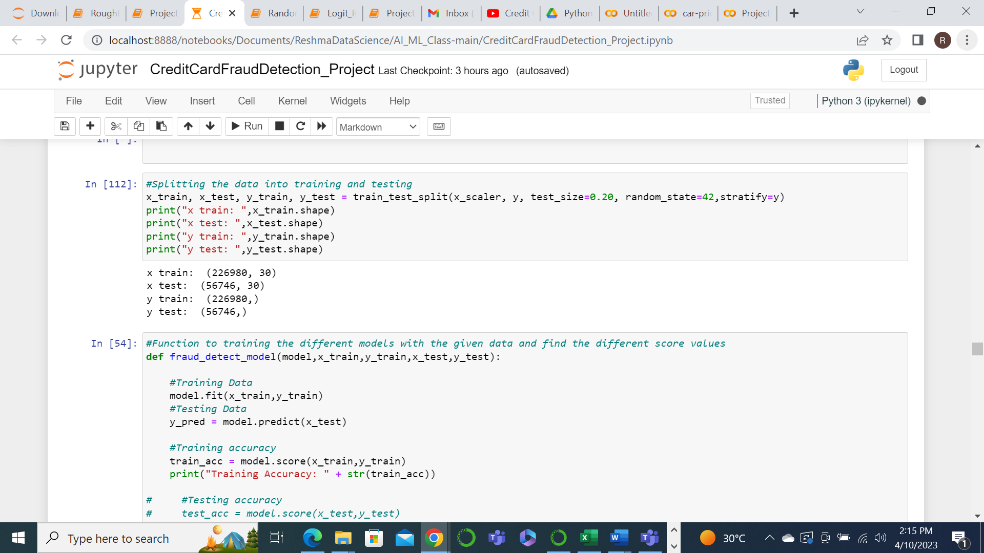

Since we need to train the model using different classification models, I have created a function for training the model which will accept the model name and the train and test data for processing and return the Testing accuracy. The function will also be printing the other metrics for evaluation.

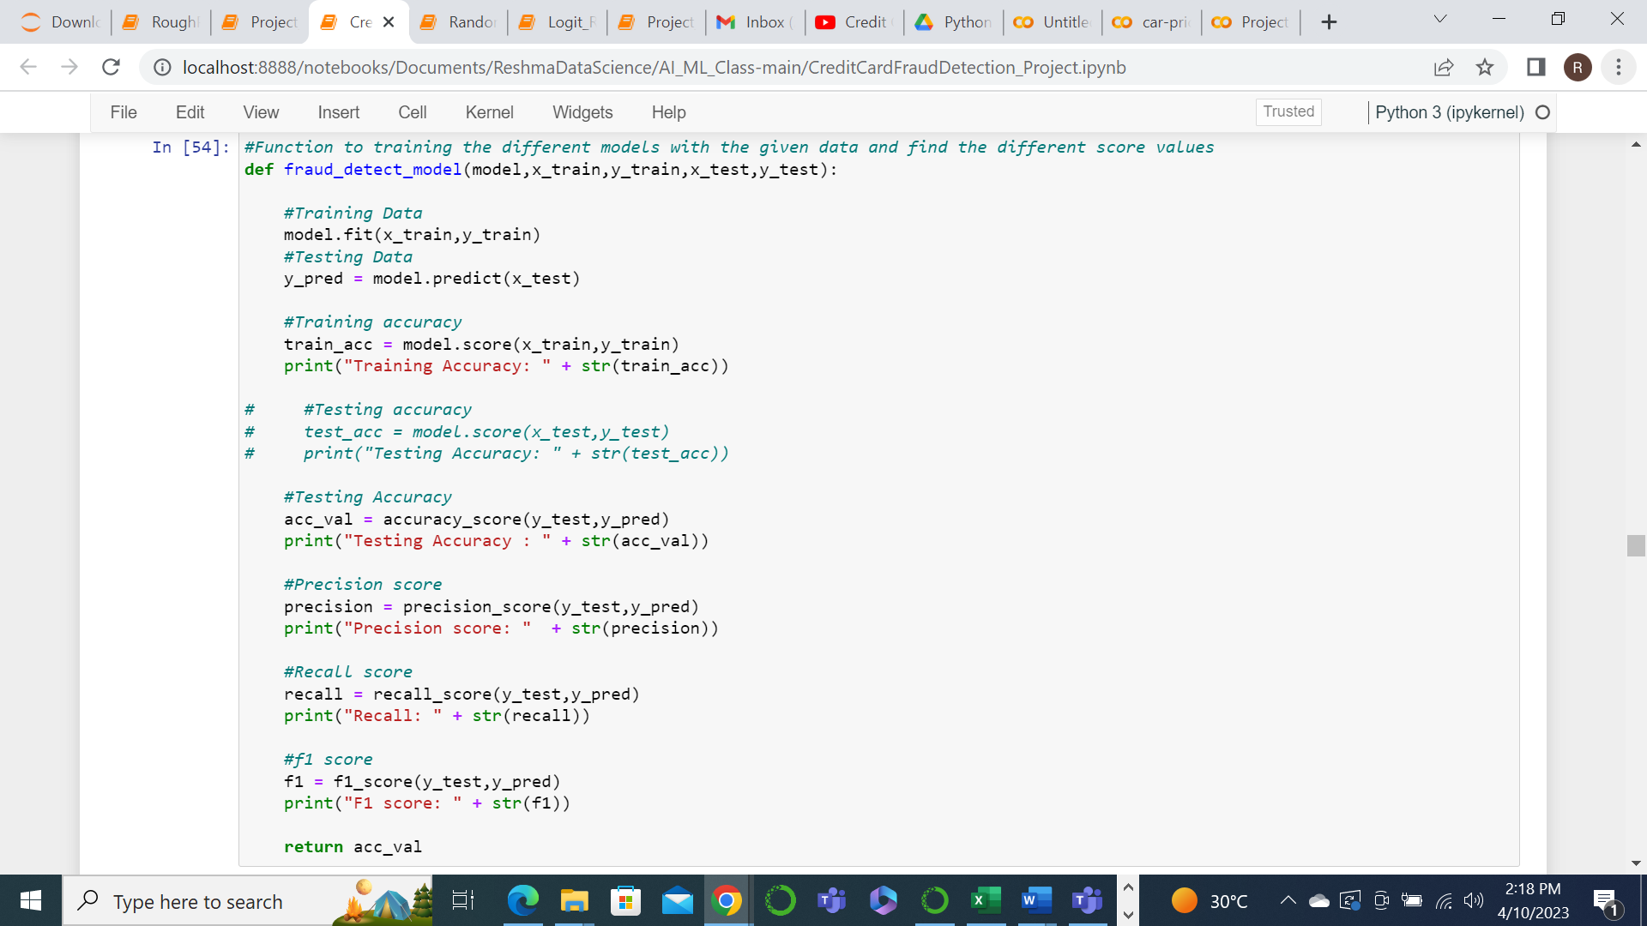

First we will look into Logistic Regression.

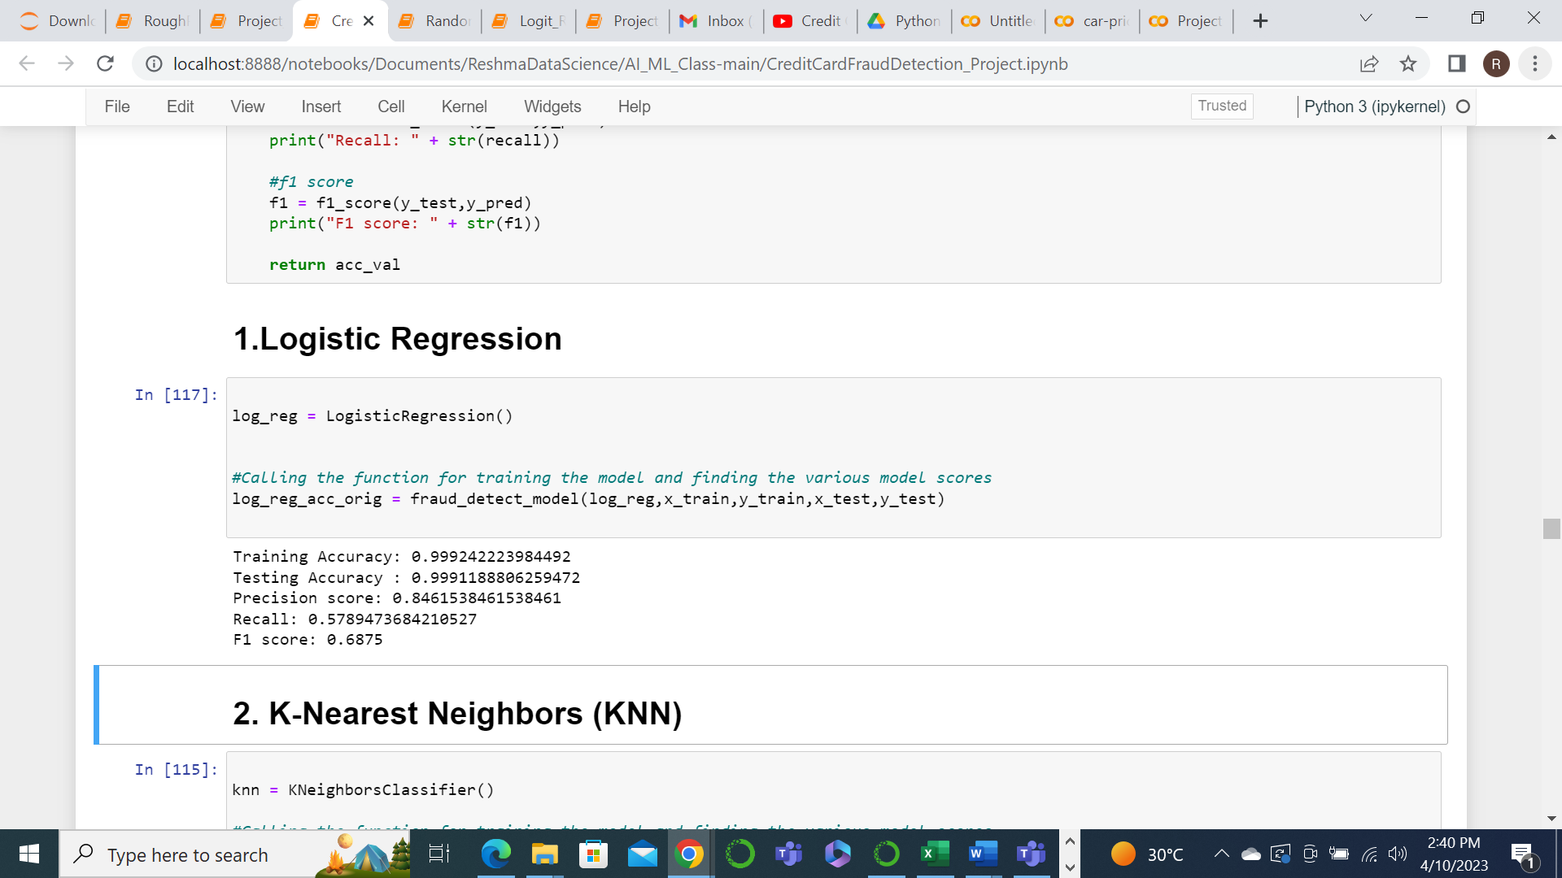

Next we will train the model with KNN

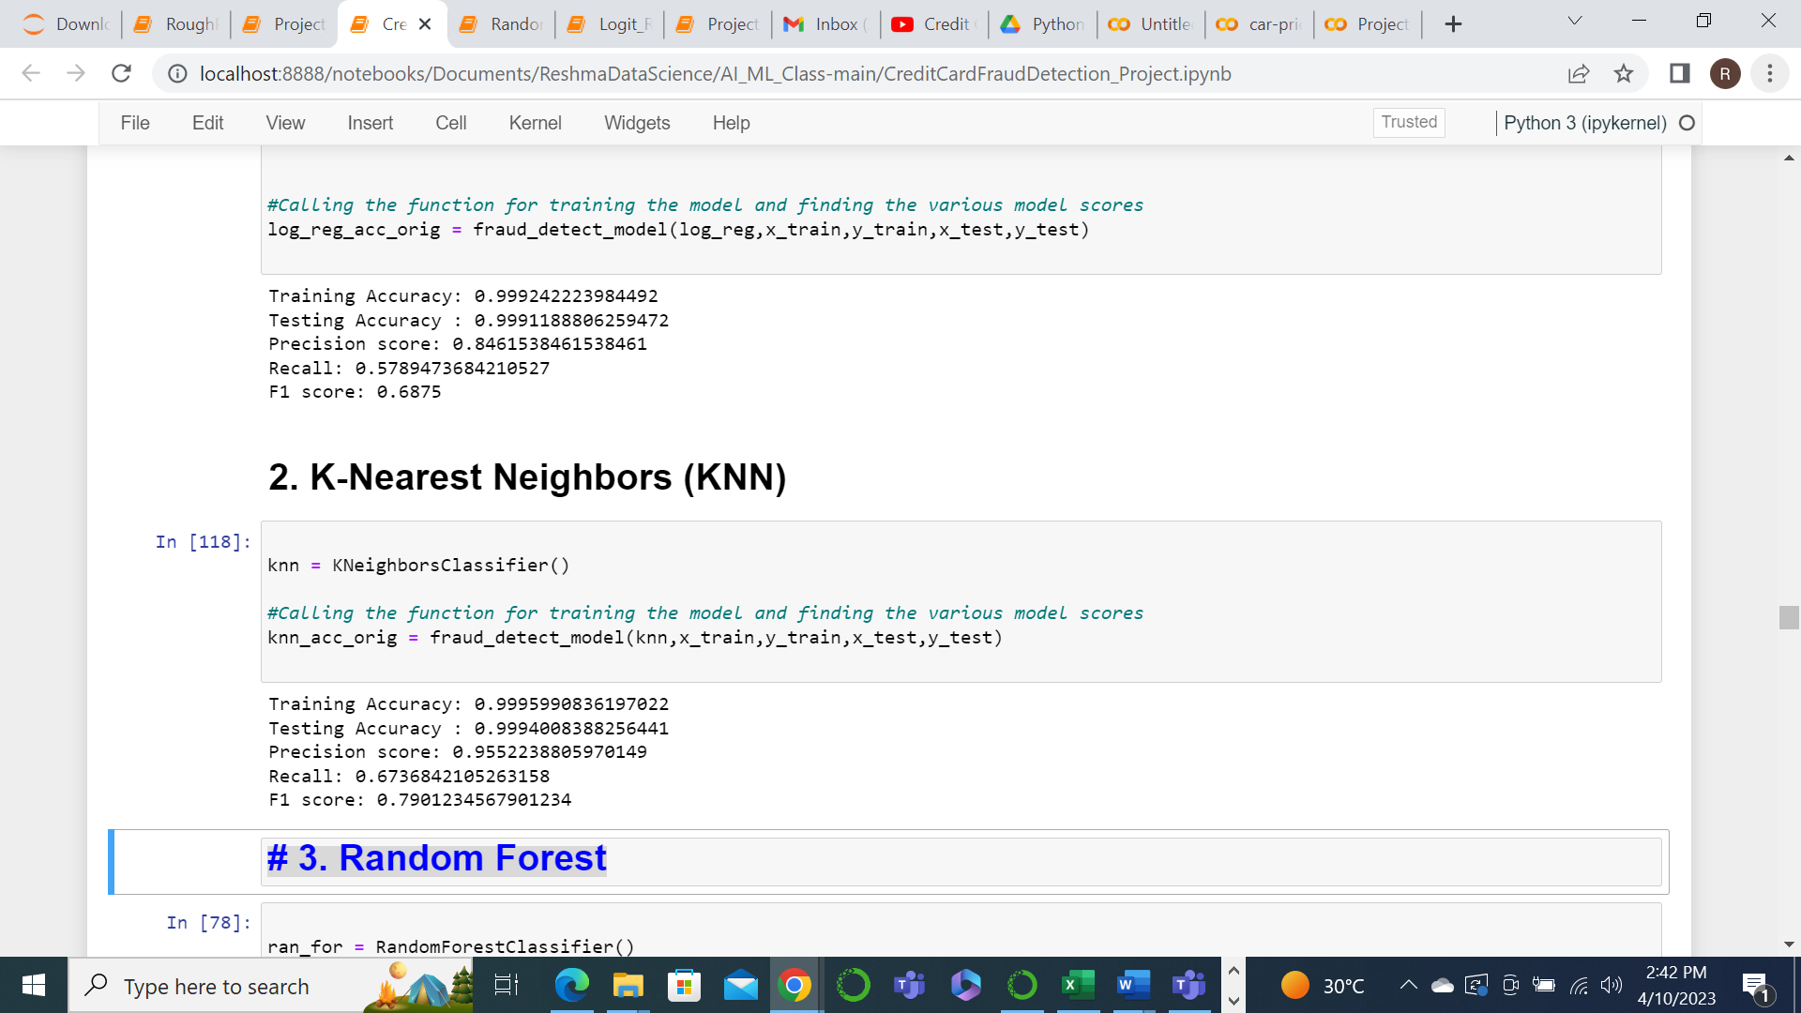

Further we will train the model using Random Forest.

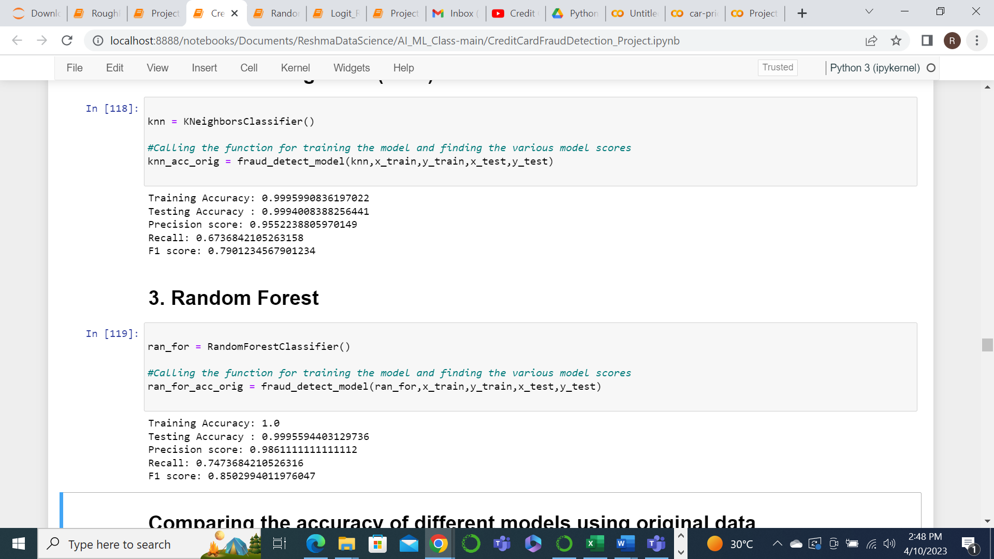

We will have a look at the accuracy of these 3 models and compare the efficiency.

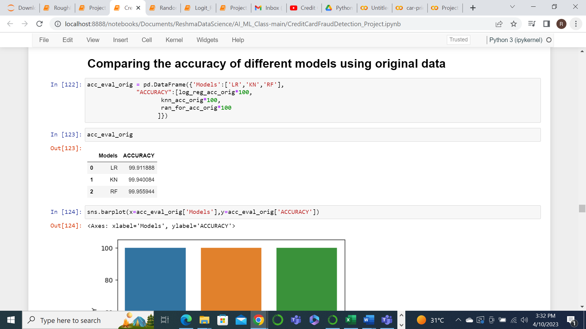

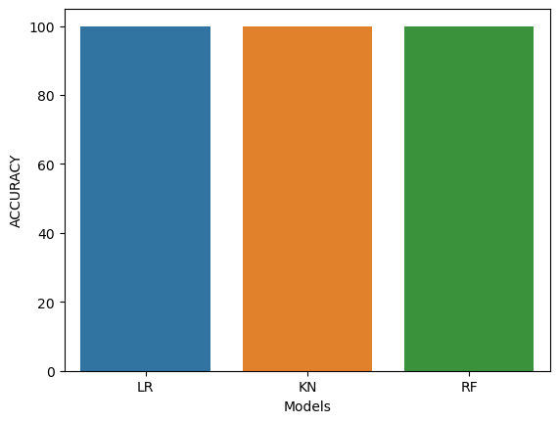

But only with the accuracy score, we will not be able to determine the efficiency of a model. That’s y we have the Precision score, Recall and F1 score also. Looking at all these we can see that Random Forest is better for now.

class imbalance

Now we also have to consider that since the no. of Fraud transactions are very less compared to Normal transactions in the dataset, the resulting train and test split also will have that imbalance. In such a scenario, if we train the model, it can either lead to overfitting or it can assume wrong correlations.

An overfitting model will assume that most cases are non-fraud where as wrong correlations can hinder the understanding of the influence of each feature on the result. To overcome this, we will have create a sub sample by way of Random Under Sampling and Over Sampling.

In Under sampling, we will be splitting the data in such a way that we will select as many transactions from the non fraud ones as there are fraud ones. So here we will be selecting 473 random transactions from the Normal transaction set along with the 473 Fraud transactions and create a sub sample.

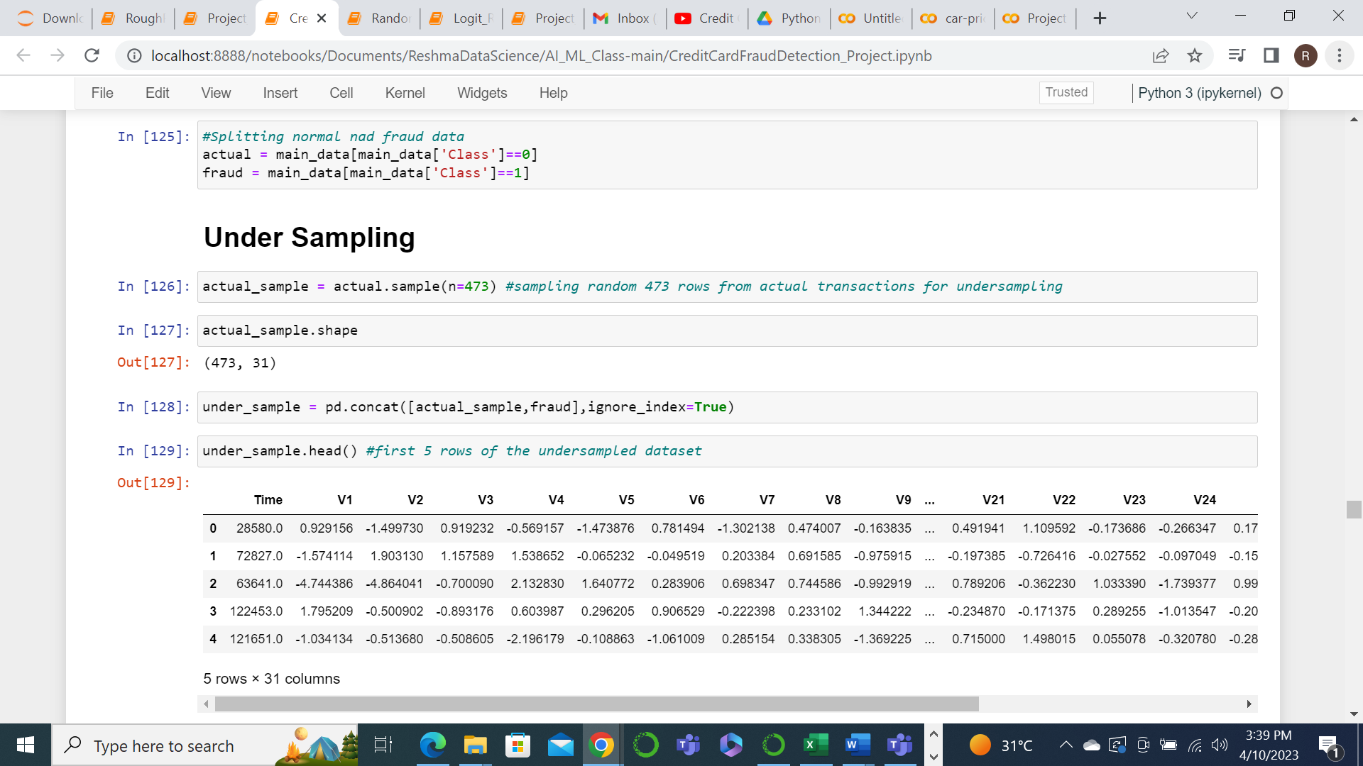

This sample will then be split into training and testing set.

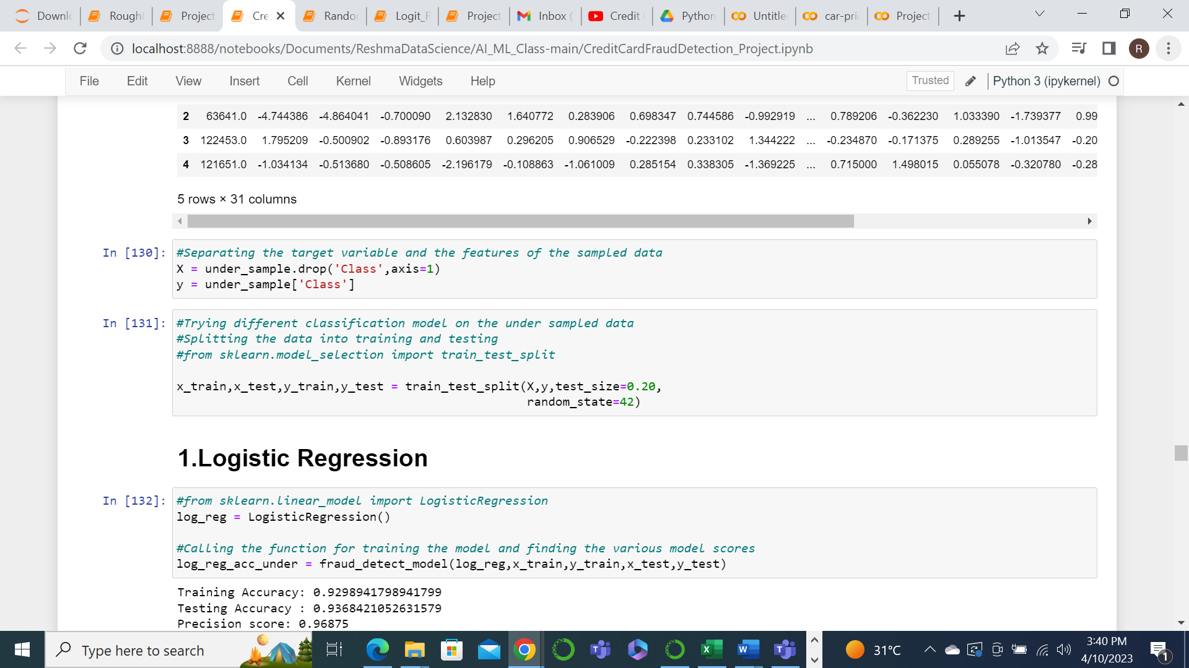

Next we will build the different models on the newly created training and test sets.

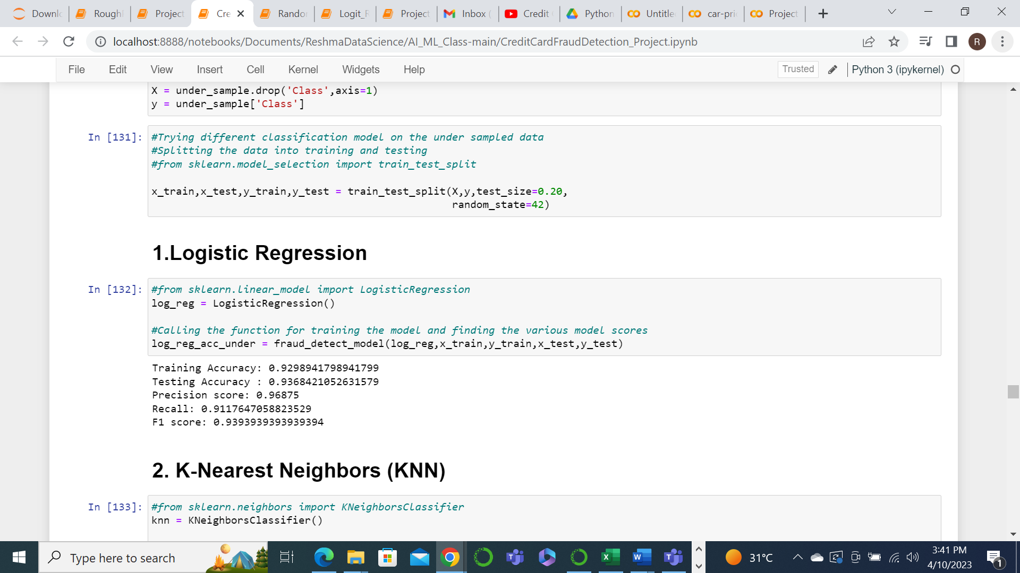

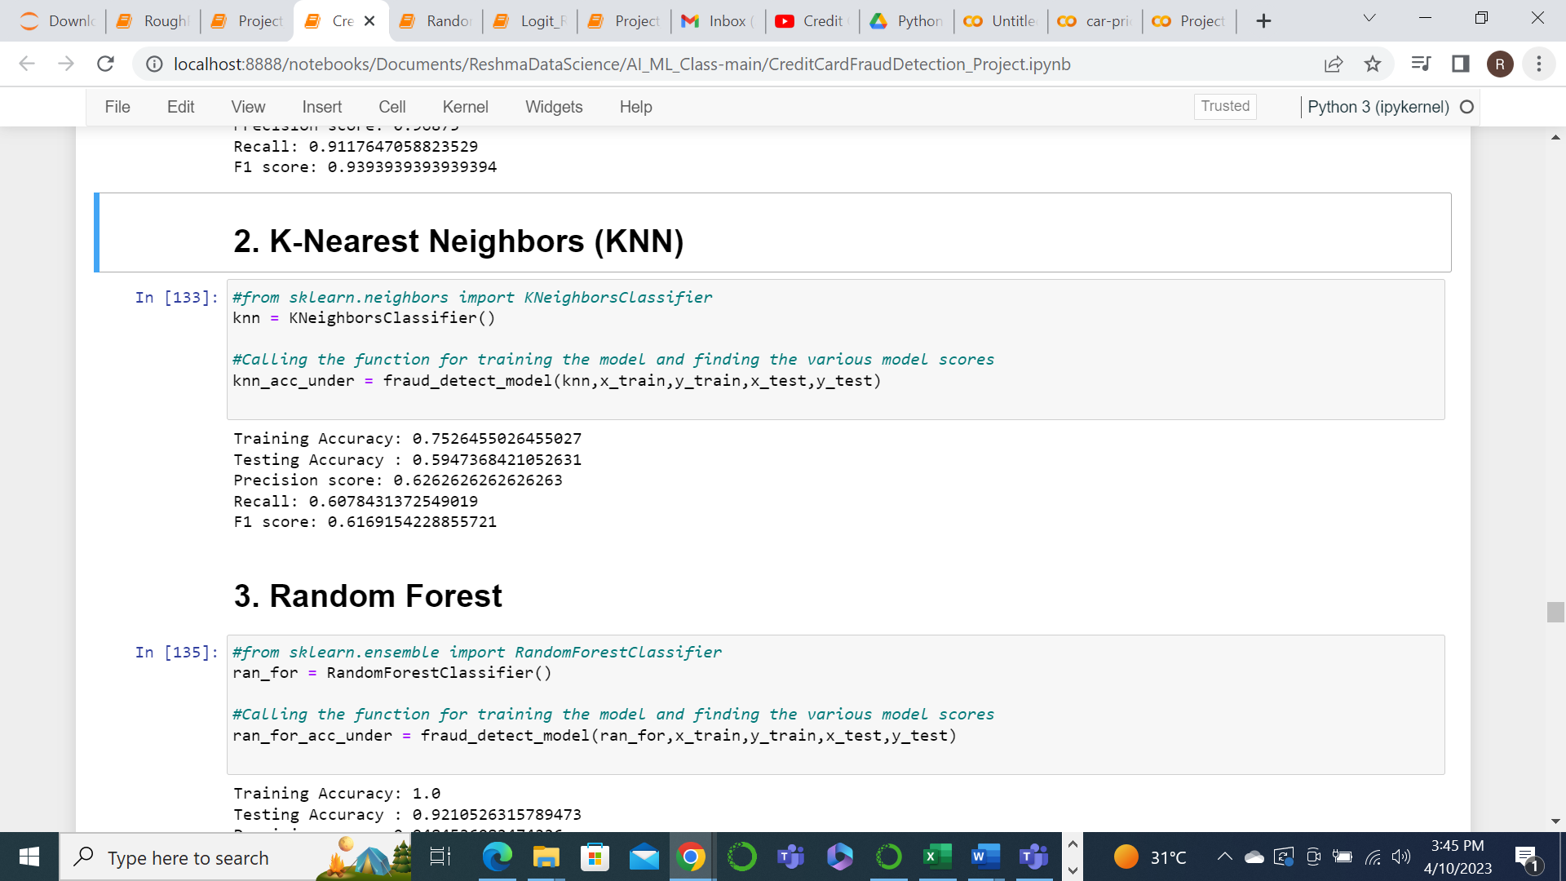

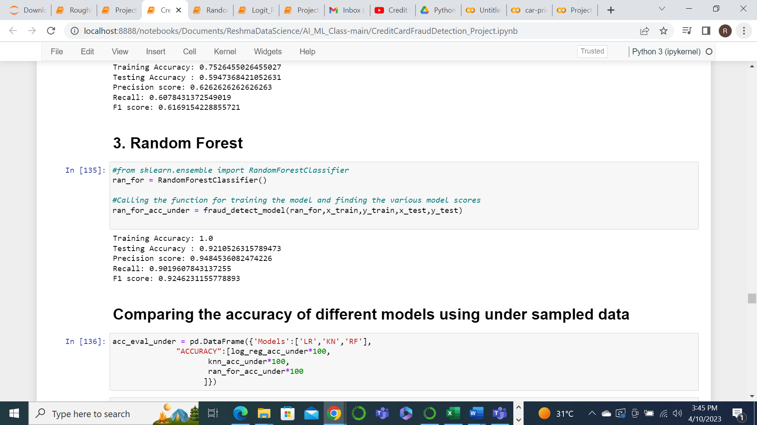

Now lets compare the accuracy score of the models after under sampling.

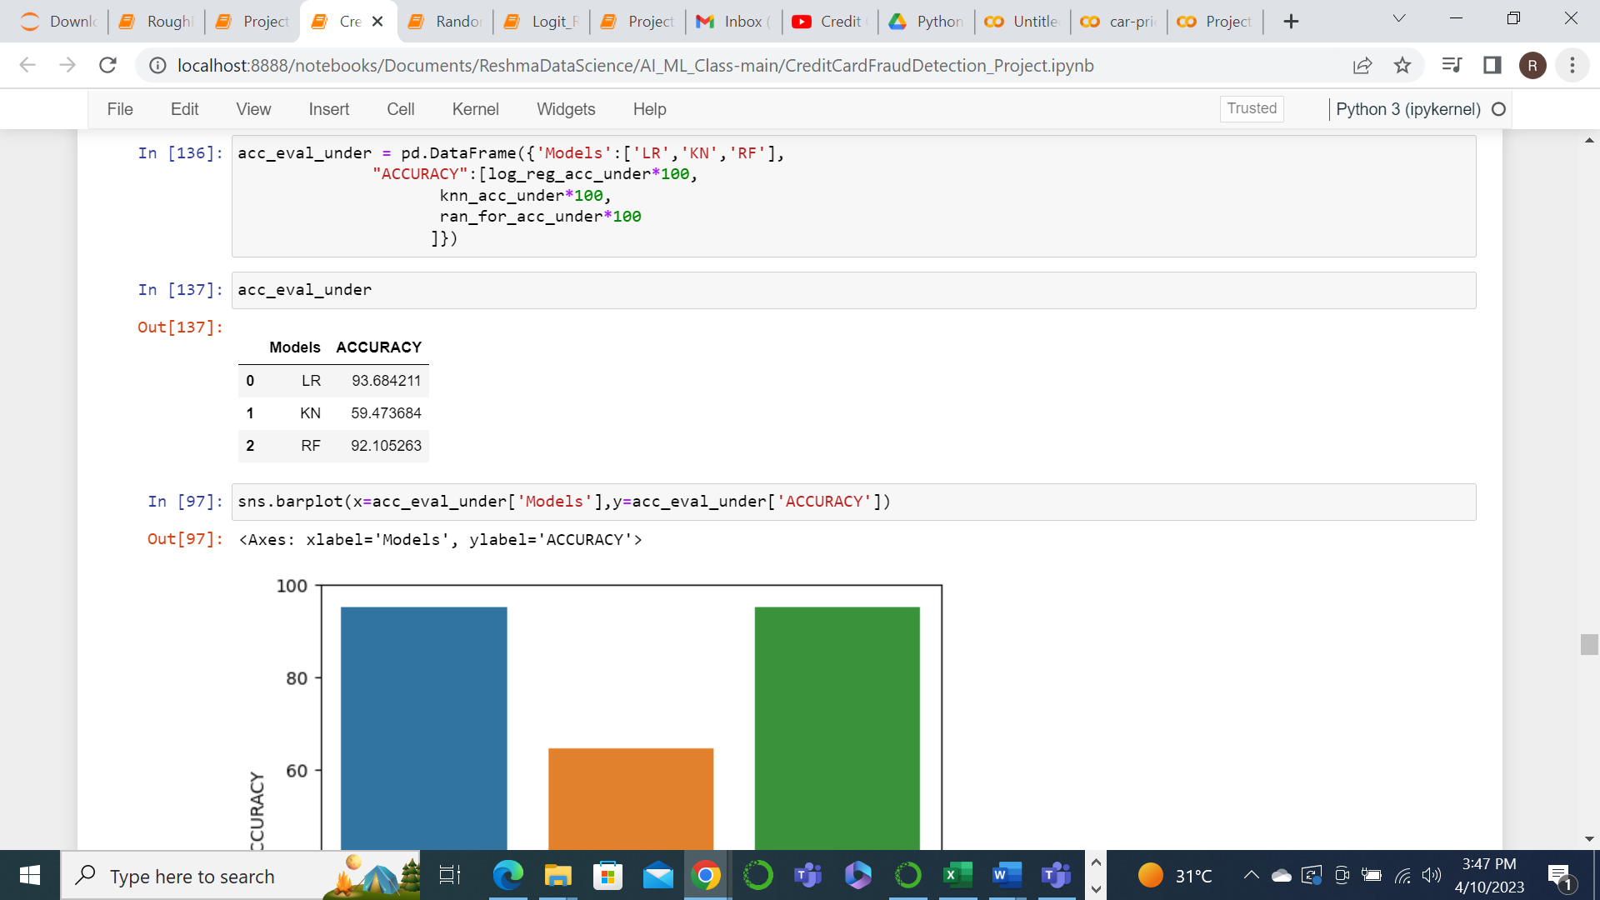

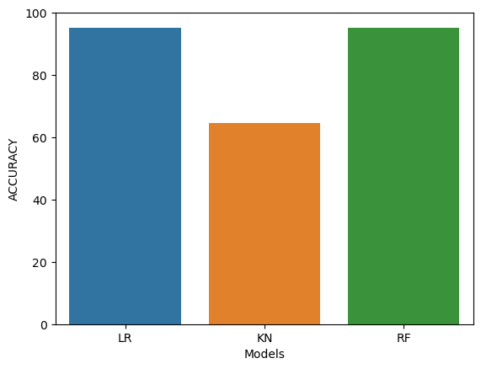

In under sampling the metrics have reduced as compared to the original data. This could also be because here we have considered only a very small subset of the data.

oversampling

Now let’s look at over sampling the data by resampling the data using SMOTE by creating as many fraud transactions as there are normal transactions in the original dataset. This will help us in eliminating the class imbalance that we had in our original dataset.

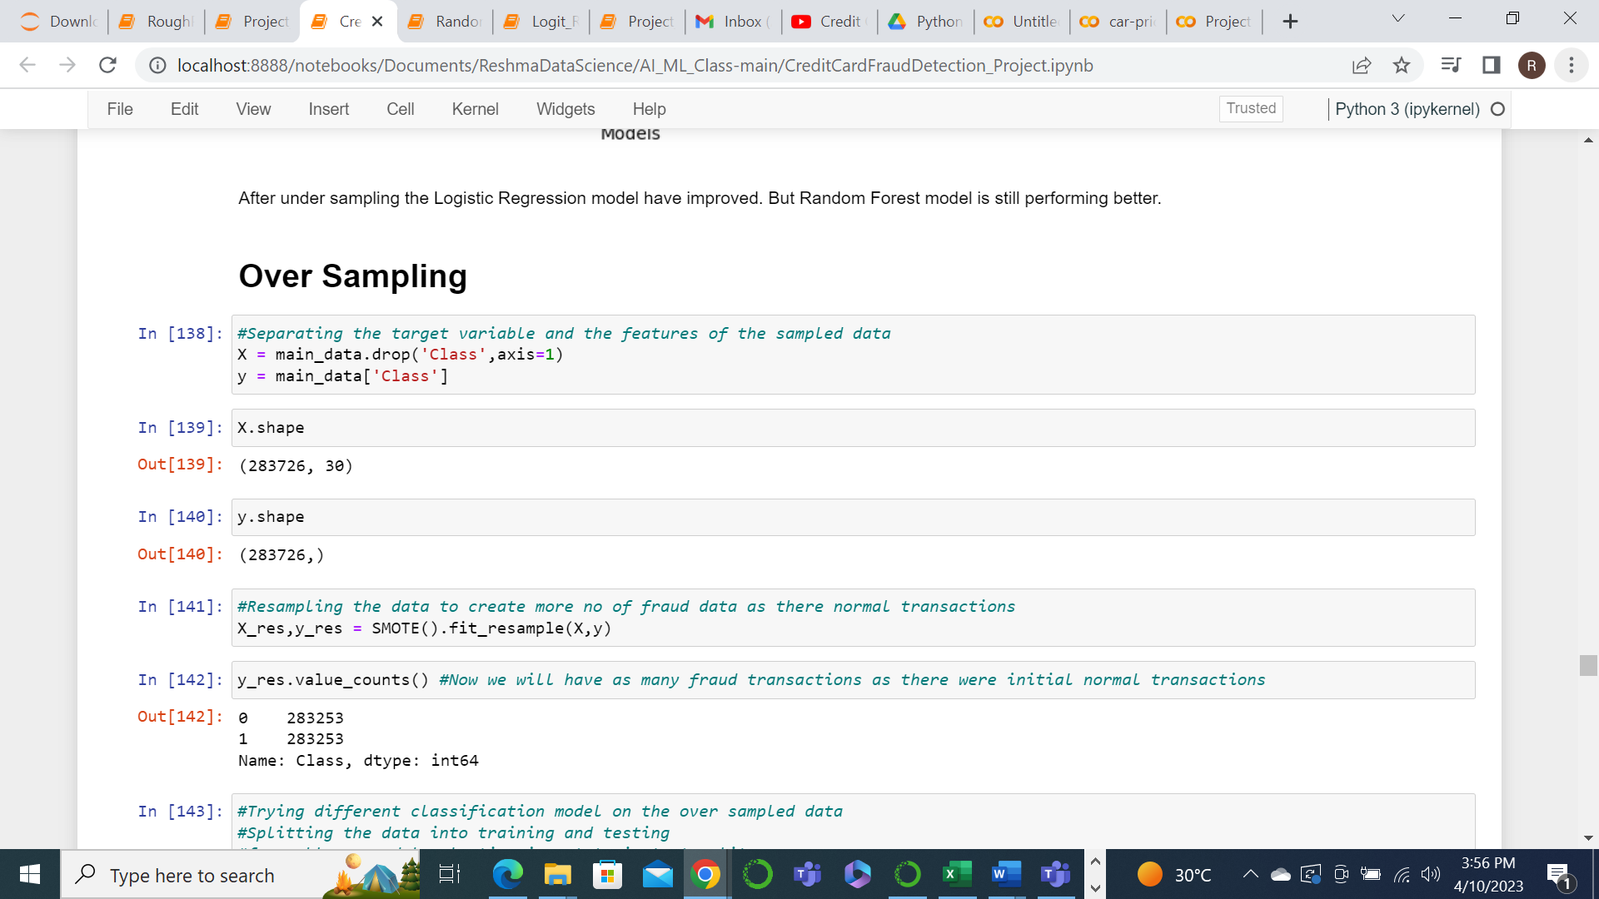

Now we will split the new data into train and test set.

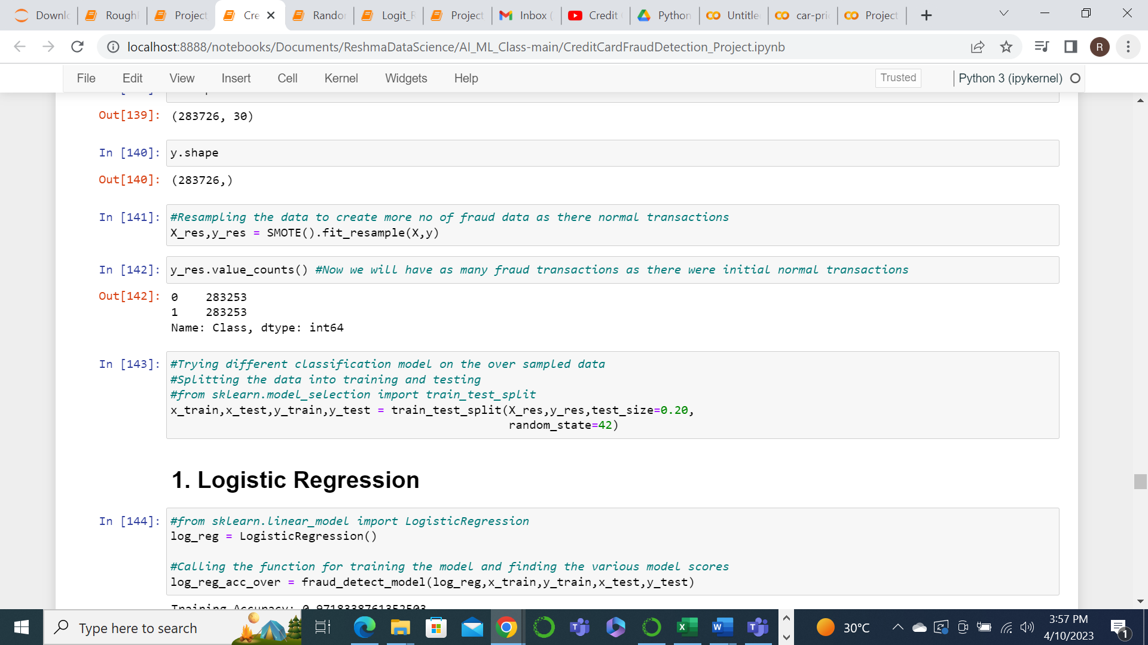

We will now train the model using the 3 models once again with the new dataset.

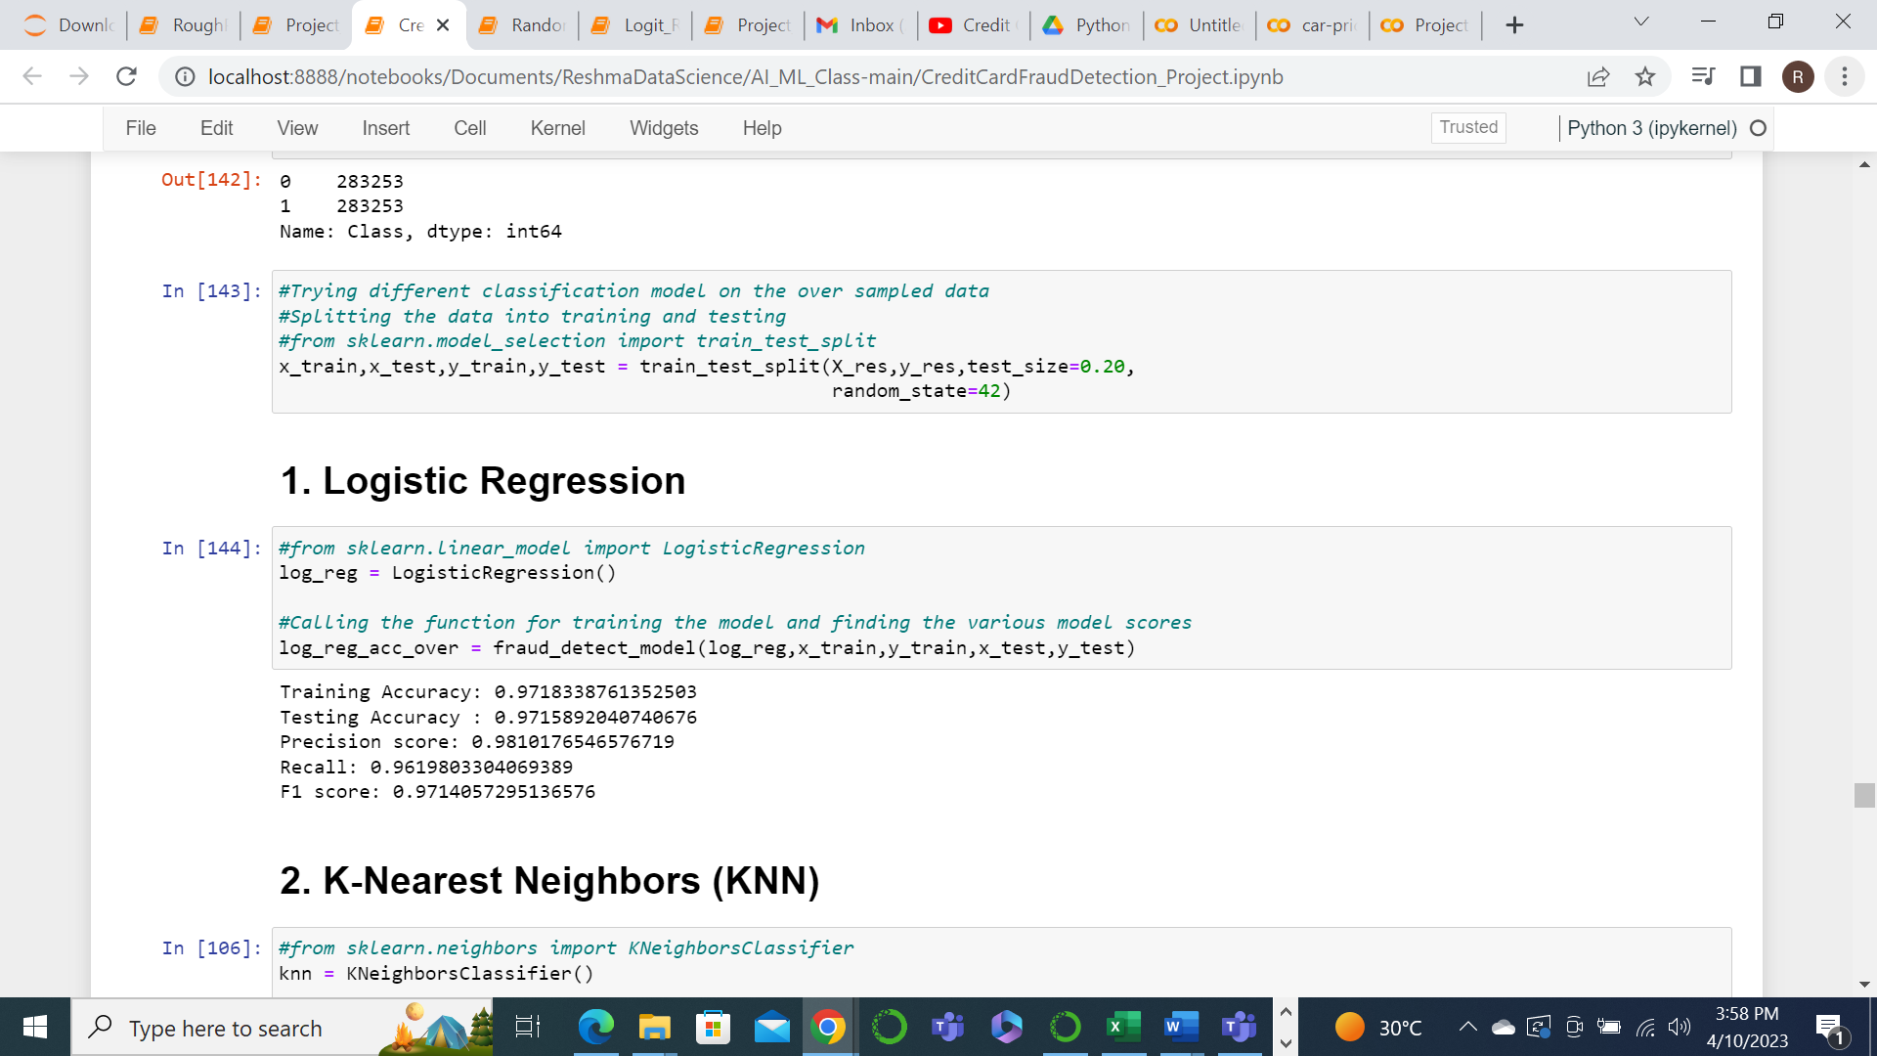

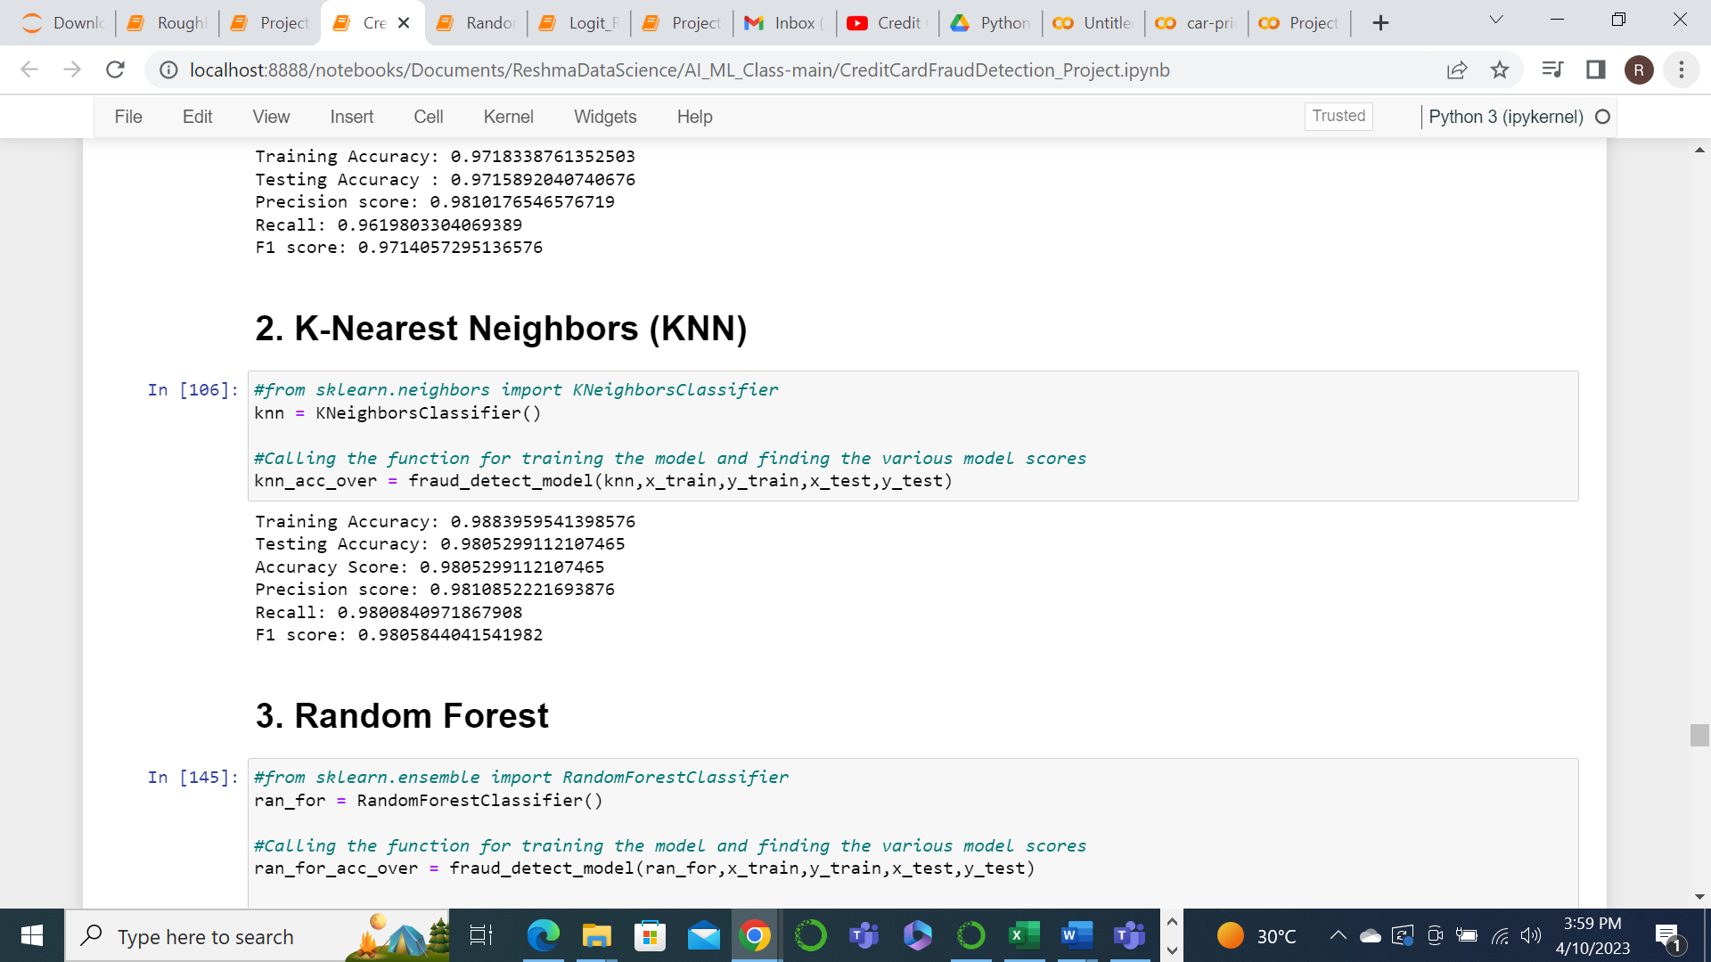

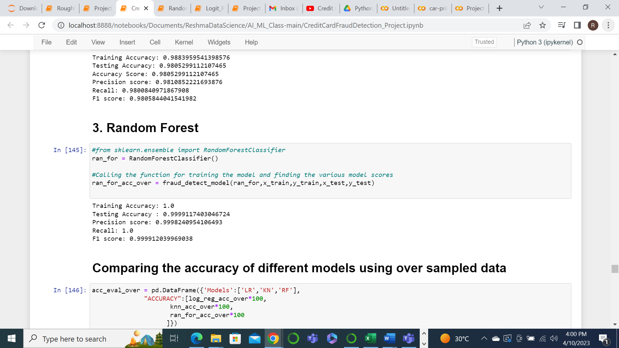

Now we can compare the accuracy of these models after over sampling.

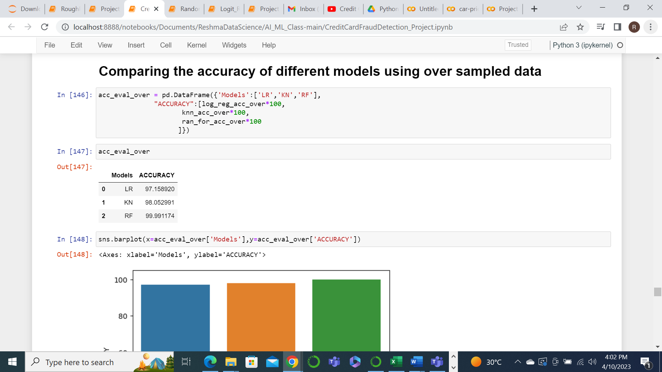

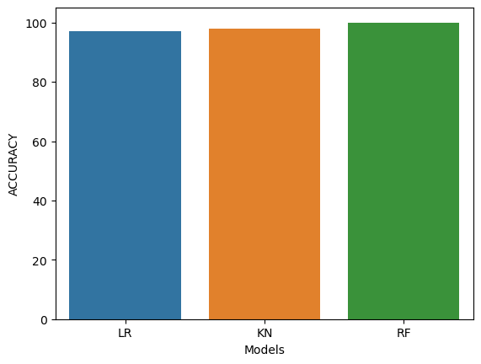

Here we can see that after oversampling, all the model accuracies have improved. But looking at the overall model accuracies and other metrics for different models, the RandomForest model after over sampling seems to be the best fit model. So we need to save this model.

best fit Model

Now we need to save the resampled data and create the model.

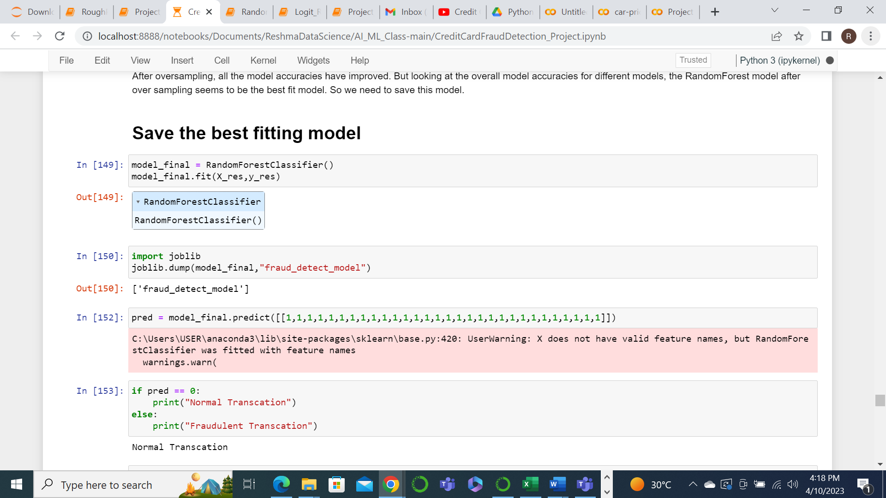

Create the model for prediction.

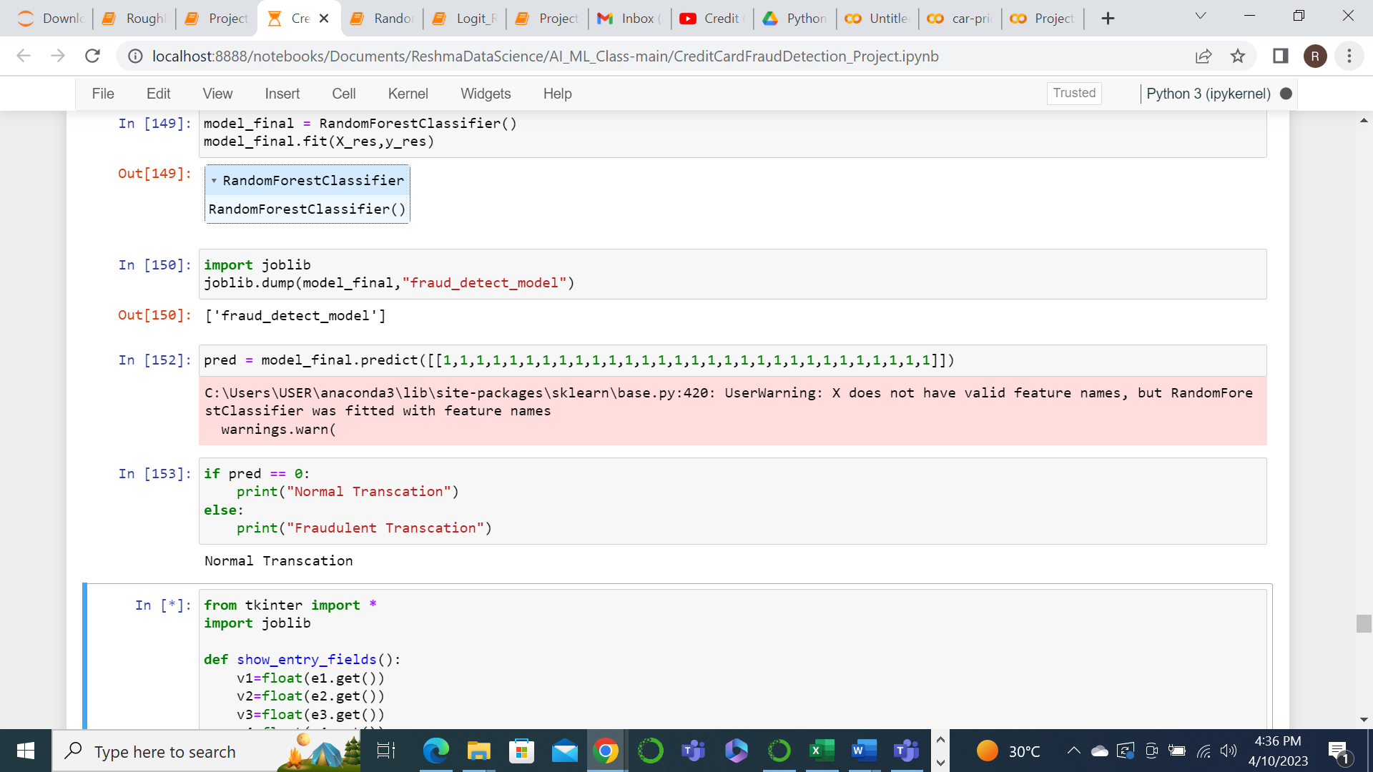

Create the web page for getting the values for each of the features to predict if the transaction is Normal or Fraud.

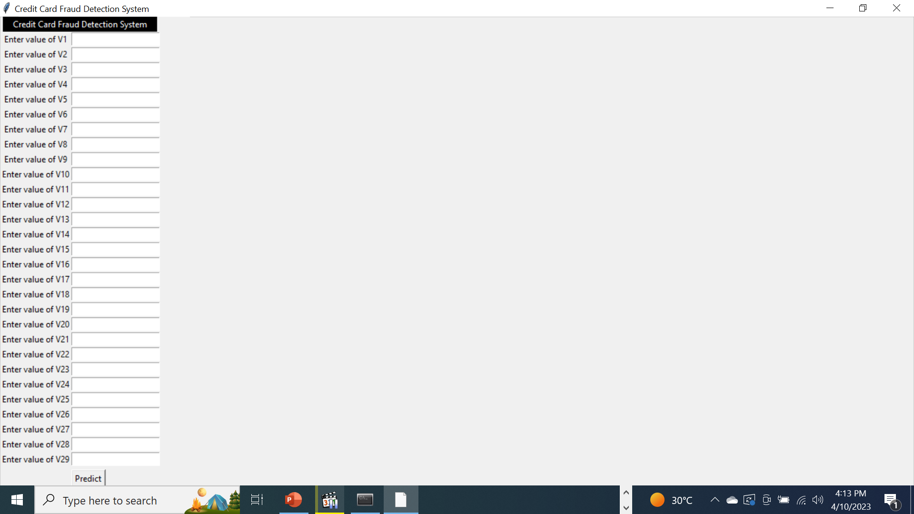

Display the output accordingly.



# conclusion

* I have been able to read, analyze the data given and preprocess the same for training the model.
* I tried 3 different classification models Logistic Regression, KNN and Random Forest for training the data.
* I also did Under sampling and Over sampling of data to understand the efficiency of the model better.
* After the model training , it is concluded that Random Forest model using resampled data has the most efficiency. So it was saved to create the model.